Drug Traceability in HealthCare Supply Chain using Blockchain Technology

1. INTRODUCTION:
In many ways, the healthcare sector is the most important part of any country's economy, and this is because it is an essential part of people's lives, contributing to their health and well-being [1]. The healthcare sector includes a wide range of enterprises, from research to industrial production to facility management. Organisations in the healthcare sector provide medical services, manufacture medical equipment and drugs, and facilitate the delivery of healthcare to patients. The bedrock of healthcare provision is effective supply chain management. This is owing to the fact that the administration of high-quality healthcare depends on the availability of medical consumables to patients at the appropriate times and in the appropriate quantities; otherwise, patients may not receive the quality care they deserve [2]. Effective supply chain management in healthcare will reduce costs, improve efficiency, and in most cases will add agility and resilience to the healthcare value chain. Due to the growing prevalence of fake and subpar drugs on the global market, the topic of drug traceability has attracted a lot of attention recently. For patient safety and the overall effectiveness of the healthcare system, it is essential to ensure the authenticity and quality of pharmaceuticals [3]. Drug tracking and tracing has proven difficult for conventional supply chain systems, necessitating the use of more sophisticated technologies. The creation of blockchain-based supply chain platforms for drug traceability is one potential remedy. With its decentralised and secure nature, blockchain technology has the ability to completely change how pharmaceuticals are tracked and traced throughout the supply chain [4]. Blockchain is a technology that combines a special set of properties to guarantee network security, transparency, and visibility, including a decentralised structure, distributed notes and storage mechanism, consensus algorithm, smart contracts, and asymmetric encryption. Furthermore, it has been described as a cutting-edge, decentralised, and distributive technology that upholds the privacy, integrity, and accessibility of all transactions and data. It is a shared, public, distributed ledger that may be used to store/record data and transactions across a peer-to-peer network that are secured by a cryptographic value [5]. In this paper, we propose a blockchain-based solution that will overcome the present issues of traceability in the pharmaceutical supply chain. The rationale for this proposed model is outline below:
• To improve drug authenticity and quality: Blockchain technology enables secure and transparent drug tracking throughout the supply chain, ensuring that patients receive genuine and high-quality medications.
• To improve efficiency and cut costs: A blockchain based supply chain system can automate supply chain processes and eliminate the need for intermediaries, resulting in more efficient and cost-effective drug tracking and tracing.
• To reduce the risk of counterfeiting: Blockchain based supply chain systems can help prevent the sale of counterfeit drugs by maintaining a tamperproof record of each drug's movement and origin.
1.1 Objective of the project:
This paper offers a blockchain-based solution for improving healthcare supply chain traceability. The suggested method establishes an indelible and unchangeable record of drug transactions using Ethereum, a decentralised blockchain platform, and the proof of stake consensus algorithm. The integrity of the data kept on the blockchain is guaranteed by smart contracts, which are used to enforce traceability. To safeguard the integrity and confidentiality of the data recorded on the blockchain, security measures are put in place. Security, performance, and scalability were used to assess the effectiveness of the proposed system. The evaluation's findings show that the suggested system is efficient at enhancing drug traceability along the supply chain and that it can manage high transaction volumes and speeds while preserving the accuracy and security of the data. According to these findings, blockchain technology has the potential to completely transform the healthcare supply chain by enhancing visibility and traceability.
2. LITERATURESURVEY:

National initiatives to promote quality of care and patient safety: achievements to date and challenges ahead

In recent years, the Ministry of Health has made major strides in increasing the public’s access to comparative data on quality, finances and patient satisfaction. Several mechanisms at multiple levels help promote quality improvement and patient safety. These include legislation, financial incentives, and national programs for quality indicators, patient experience, patient safety, prevention and control of infection and accreditation. Over the years, improvements in quality indicators, infection prevention and patient satisfaction can be demonstrated, but other fields show little change, if at all. Challenges and barriers include reluctance by unions, inconsistent and unreliable flow of information, the fear of overpressure by management and the loss of autonomy by physicians, and doubts regarding “gaming” of data. Accreditation has its own challenges, such as the need to adjust it to local characteristics of the healthcare system, its high cost, and the limited evidence of its impact on quality. Lack of interest by leaders, lack of resources, burnout and compassion fatigue, are listed as challenges for improving patient experience.

High-quality health systems in the Sustainable Development Goals era: time for a revolution

Although health outcomes have improved in low-income and middle-income countries (LMICs) in the past several decades, a new reality is at hand. Changing health needs, growing public expectations, and ambitious new health goals are raising the bar for health systems to produce better health outcomes and greater social value. But staying on current trajectory will not suffice to meet these demands. What is needed are high-quality health systems that optimise health care in each given context by consistently delivering care that improves or maintains health, by being valued and trusted by all people, and by responding to changing population needs. Quality should not be the purview of the elite or an aspiration for some distant future; it should be the DNA of all health systems. Furthermore, the human right to health is meaningless without good quality care because health systems cannot improve health without it.

Engaging patients to improve quality of care: a systematic review
Background: To identify the strategies and contextual factors that enable optimal engagement of patients in the design, delivery, and evaluation of health services.
Methods: We searched MEDLINE, EMBASE, CINAHL, Cochrane, Scopus, PsychINFO, Social Science Abstracts, EBSCO, and ISI Web of Science from 1990 to 2016 for empirical studies addressing the active participation of patients, caregivers, or families in the design, delivery and evaluation of health services to improve quality of care. Thematic analysis was used to identify (1) strategies and contextual factors that enable optimal engagement of patients, (2) outcomes of patient engagement, and (3) patients' experiences of being engaged.
Results: Forty-eight studies were included. Strategies and contextual factors that enable patient engagement were thematically grouped and related to techniques to enhance design, recruitment, involvement and leadership action, and those aimed to creating a receptive context. Reported outcomes ranged from educational or tool development and informed policy or planning documents (discrete products) to enhanced care processes or service delivery and governance (care process or structural outcomes). The level of engagement appears to influence the outcomes of service redesign-discrete products largely derived from low-level engagement (consultative unidirectional feedback)-whereas care process or structural outcomes mainly derived from high-level engagement (co-design or partnership strategies). A minority of studies formally evaluated patients' experiences of the engagement process (n = 12; 25%). While most experiences were positive-increased self-esteem, feeling empowered, or independent-some patients sought greater involvement and felt that their involvement was important but tokenistic, especially when their requests were denied or decisions had already been made.
Conclusions: Patient engagement can inform patient and provider education and policies, as well as enhance service delivery and governance. Additional evidence is needed to understand patients' experiences of the engagement process and whether these outcomes translate into improved quality of care.

A review study of the blockchain-based healthcare supply chain

Technological acclimatization in today's healthcare industry is a subject of new inventions. The worldwide Covid-19 epidemic has led to increase in the use of technology for healthcare supply chain, patient data management, and claims settlement. Data management in healthcare industry is a complex structure where multiple organizations provide proper supply chain services in day to day life. Improper data management disrupts the supply chain, which has a long-term impact on the healthcare sector. Various issues in the present supply chain must be addressed. Blockchain-based crypto-currencies are well-known nowadays for their ability to create safe and traceable solutions. With the growing use of crypto-currencies, it also governs new range of applications and opportunities, including healthcare applications. Blockchain-based solutions are effective in the health sector for secure data retrieval and storage, resulting in more effectual product creation and tracking. Such system can provide data provenance, promotes genuine healthcare sector demands, and ensures the immutability of multi-direction transactions. In this study, we contribute a thorough overview of the literature on how Blockchain technology is changing the way healthcare supply chains operate. We looked at 61 papers from 2019 to 2021 that highlighted various difficulties with the traditional healthcare supply chain. We scrutinized different barriers and opportunity of Blockchain-based healthcare supply chain at the end of the research.

Blockchain-technology-supported platforms for diamond authentication and certification in luxury supply chains

The blockchain technology is very useful in many industries. One current application is on diamond authentication and certification, which is important in many luxury supply chains. In this paper, we explore different consumer utility driven operations models and highlight the values of blockchain technology supported (BTS) platforms for diamond authentication and certification. We build models and analytically examine both the traditional retail network operations (Model R) and the BTS selling platform (Model PL). We further extend the analysis to study the case with the BTS certification platform (Model BCR). We reveal the conditions under which one model outperforms the others. In particular, we note that the shopping convenience utility offered by the traditional retailers is a critical factor determining which model is the best. Finally, for the BTS platform operations, we study the blockchain-technology-based diamond authentication and certification (BDAC) cost and reveal that reducing it is beneficial to all parties in the luxury supply chain.

Supply chain disruptions and resilience: a major review and future research agenda

Our study examines the literature that has been published in important journals on supply chain disruptions, a topic that has emerged the last 20 years, with an emphasis in the latest developments in the field. Based on a review process important studies have been identified and analysed. The content analysis of these studies synthesized existing information about the types of disruptions, their impact on supply chains, resilience methods in supply chain design and recovery strategies proposed by the studies supported by cost–benefit analysis. Our review also examines the most popular modelling approaches on the topic with indicative examples and the IT tools that enhance resilience and reduce disruption risks. Finally, a detailed future research agenda is formed about SC disruptions, which identifies the research gaps yet to be addressed. The aim of this study is to amalgamate knowledge on supply chain disruptions which constitutes an important and timely as the frequency and impact of disruptions increase. The study summarizes and builds upon the knowledge of other well-cited reviews and surveys in this research area.

Impact of Track and Trace integration on pharmaceutical production systems”. International Journal of Engineering Business Management

In today's competitive economic environment, track and trace (the capability to determine present and past locations of products through the whole supply chain is becoming an increasingly urgent necessity and a key differentiator in many industries, enhancing pill forage reduction, counterfeit prevention and targeted recalls, and improving supply chain efficiency, synchronization, visibility, and security. The pharmaceutical industry, together with the food industry, is one of the most advanced in traceability system implementation, as it has found to be strongly affected by the counterfeiting phenomenon. In this paper, a brief overview of traceability international regulations in the pharmaceutical sector and of the impact of its implementation on production processes and logistics will be continued, in order to highlight the main drivers of its large and fast diffusion. Technologies developed will also be presented and criticalities, and the benefits of traceability system implementation will be analysed.

Implementing pharmaceutical track- and-trace systems: A realist review

Introduction One way to prevent falsified medical products from entering the regulated pharmaceutical supply chain is to implement a pharmaceutical track-and-trace system (PTTS). Such systems in the most extensive versions generally mandate a scan at every point of contact with the medical product: from the point of entry to dispensation. There have been several attempts to implement such systems; for example, a ‘full’ PTTS in Turkey and the more pared-down version offered by the European Union’s Falsified Medicines Directive and Delegated Act. This study aims to identify facilitators and barriers to implementing (elements of) a PTTS, with the Turkish system used as a benchmark. Methods We conducted a ‘realist’ review, which synthesises literature and aims to establish how a specific technology works, for whom, under which circumstances. We searched Embase, Medline Ovid, Web of Science, Cochrane Central and Google Scholar databases, yielding 2,790 scholarly articles. We selected 21 for review. Results Implementation of PTTS elements has been attempted in different compositions in several primarily high-income and middle-income countries. Factors that affected implementation included stakeholders like the government and supply chain actors, the coordination between them, and their awareness, knowledge, and skills, as well as regulation and legislation, monetary investments, and technical and digital requirements. Conclusion The interplay between contextual factors is crucial for successful PTTS implementation. Specifically, the findings indicate that aligning the incentives for all actors and allowing for adjustments in a continuous implementation process will likely facilitate implementation.

Pharmaceutical Serialization : A Challenge for Small Manufacturers
The purpose of this paper is to focus on the Challenges faced by Small Manufacturers due to the Serialization compliance. Pharmaceutical serialization is the process of assigning unique serial number to each saleable product pack. Each product pack contains information about product source, Global Trade Identification Number (GTIN), Batch number, Expiry date and unique serial number. Pharmaceutical serialization is not new compliance, and it was initially introduced by Turkey in 2010, and other market such as the China and South Korea. Since many years China made compulsory for all supply chain partners to record drug distribution information of individuals drugs units in a traceability system. As we are approaching to 2023, It will be final phase of 10 yearlong implementation of Drug Supply Chain Security Act (DSCSA) since compliance enacted in 2013. Verification router services (Saleable Return) is another compliance which was scheduled to enforce on 2020 but it is now push back to 2023 due to Covid-19 impact. Under 2023 DSCSA Act, manufacturers need to provide product tracing information in secure and interoperable manner electronically to distributors and wholesaler in supply chain. Wholesaler must transfer product tracing information to dispensers and pharmacy and verify saleable returns receive from supply chain stakeholders. Dispenser/Pharmacy should be able to receive Electronic Product Code Information Services (EPCIS) and product tracing information electronically and to be able to reconcile physical product unique identifier with electronic records. Finally, everyone in supply chain must be connected electronically through interoperable network which will allow regulatory bodies to track and trace the information’s. The importance of drug traceability has been increasingly emphasized and mandated by several countries across the world. The Drug Supply Chain Security Act (DSCSA) has been working on a pilot project with big pharmaceutical companies, wholesalers and distributors to design and test interoperable network to trace pharmaceutical prescribed drug electronically at package level. This will help supply chain stakeholders to verify the authenticity of drug in United States.

Critical Success Factors and Traceability Technologies for Establishing a Safe Pharmaceutical Supply Chain

Drug counterfeits have been an international issue for almost two decades, and the latest statistics show that fake medications will continue to penetrate legitimate pharmaceutical supply chains (PSCs). Therefore, identifying the issues faced by PSCs is essential to combat the counterfeit drug problem, which will require the implementation of technologies in various phases of the PSC to gain better visibility. In this regard, a literature review was conducted to fulfill the following objectives: (i) review the application of traceability technologies in various PSC phases to detect counterfeits; (ii) analyze the various barriers affecting the establishment of a safe PSC and the critical success factors used to overcome those barriers; and (iii) develop a conceptual framework and guidelines to demonstrate the influence of traceability technologies and success factors on overcoming the various barriers in different phases of the PSC. The major finding of this review was that traceability technologies and the critical success factors have a significant influence on overcoming the barriers to establishing a safe PSC.

EduCTX: A Blockchain-Based Higher Education Credit Platform
Blockchain technology enables the creation of a decentralized environment where transactions and data are not under the control of any third party organization. Any transaction ever completed is recorded in a public ledger in a verifiable and permanent way. Based on blockchain technology, we propose a global higher education credit platform, named EduCTX. This platform is based on the concept of the European Credit Transfer and Accumulation System (ECTS). It constitutes a globally trusted, decentralized higher education credit and grading system that can offer a globally unified viewpoint for students and higher education institutions (HEIs), as well as for other potential stakeholders such as companies, institutions, and organizations. As a proof of concept, we present a prototype implementation of the environment, based on the open-source Ark Blockchain Platform. Based on a globally distributed peer-to-peer network, EduCTX will process, manage and control ECTX tokens, which represent credits that students gain for completed courses such as ECTS. HEIs are the peers of the blockchain network. The platform is a first step towards a more transparent and technologically advanced form of higher education systems. The EduCTX platform represents the basis of the EduCTX initiative which anticipates that various HEIs would join forces in order to create a globally efficient, simplified and ubiquitous environment in order to avoid language and administrative barriers. Therefore we invite and encourage HEIs to join the EduCTX initiative and the EduCTX blockchain network.

3. SYSTEM ANALYSIS
3.1 Existing System
In Existing supply chain managements are based on centralized server and if this server down then traceability becomes impossible and there is a chance that if centralized server hack then there is no possible mean to recover or extract hacking details.
Due to above centralized server disadvantages many organizations are moving or migrating their application to Blockchain.
DISADVANTAGE:
- Less Secure
3.2 Proposed System
In Propose we use blockchain technology to promote transparency, data integrity, and data immutability. Additionally, we explain the role of each stakeholder and component in our solution. In proposed solution will function fully on smart contracts. In order to create smart contracts, Solidity, the programming language built on Ethereum, will be used. These smart contracts will outline the procedures and logic for tracking the movement of pharmaceuticals along the supply chain and capturing and updating data about the drugs themselves. The Ethereum network will then deploy nodes to host the smart contracts and take part in the proof of stake consensus procedure, confirming transactions and preserving the accuracy of the medication traceability information. For transparency and traceability, this data will be accessible to authorised parties and immutably kept on the Ethereum blockchain.
ADVANTAGE:
- More Secure
3.3. PROCESS MODEL USED WITH JUSTIFICATION
SDLC (Umbrella Model):
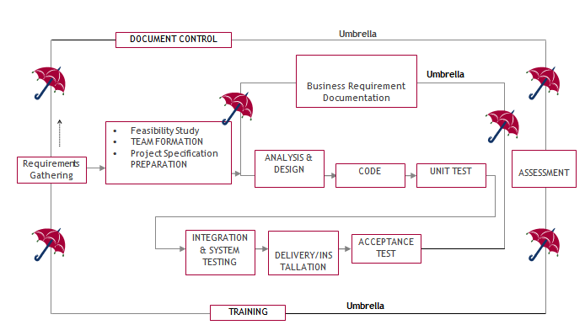
The requirements gathering process takes as its input SDLC is nothing but Software Development Life Cycle. It is a standard which is used by software industry to develop good software.
Stages in SDLC:
- Requirement Gathering
- Analysis
- Designing
- Coding
- Testing
- Maintenance
Requirements Gathering stage:
the goals identified in the high-level requirements section of the project plan. Each goal will be refined into a set of one or more requirements. These requirements define the major functions of the intended application, define operational data areas and reference data areas, and define the initial data entities. Major functions include critical processes to be managed, as well as mission critical inputs, outputs and reports. A user class hierarchy is developed and associated with these major functions, data areas, and data entities. Each of these definitions is termed a Requirement. Requirements are identified by unique requirement identifiers and, at minimum, contain a requirement title and textual description.
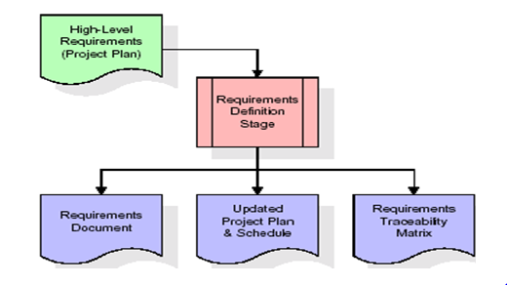

These requirements are fully described in the primary deliverables for this stage: the Requirements Document and the Requirements Traceability Matrix (RTM). The requirements document contains complete descriptions of each requirement, including diagrams and references to external documents as necessary. Note that detailed listings of database tables and fields are not included in the requirements document.
The title of each requirement is also placed into the first version of the RTM, along with the title of each goal from the project plan. The purpose of the RTM is to show that the product components developed during each stage of the software development lifecycle are formally connected to the components developed in prior stages.
In the requirements stage, the RTM consists of a list of high-level requirements, or goals, by title, with a listing of associated requirements for each goal, listed by requirement title. In this hierarchical listing, the RTM shows that each requirement developed during this stage is formally linked to a specific product goal. In this format, each requirement can be traced to a specific product goal, hence the term requirements traceability.
The outputs of the requirements definition stage include the requirements document, the RTM, and an updated project plan.
- Feasibility study is all about identification of problems in a project.
- No. of staff required to handle a project is represented as Team Formation, in this case only modules are individual tasks will be assigned to employees who are working for that project.
- Project Specifications are all about representing of various possible inputs submitting to the server and corresponding outputs along with reports maintained by administrator.
Analysis Stage:
The planning stage establishes a bird's eye view of the intended software product, and uses this to establish the basic project structure, evaluate feasibility and risks associated with the project, and describe appropriate management and technical approaches.
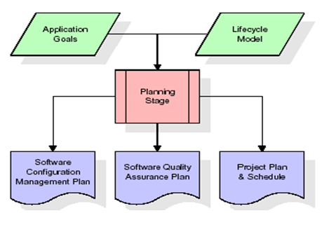

The most critical section of the project plan is a listing of high-level product requirements, also referred to as goals. All of the software product requirements to be developed during the requirements definition stage flow from one or more of these goals. The minimum information for each goal consists of a title and textual description, although additional information and references to external documents may be included. The outputs of the project planning stage are the configuration management plan, the quality assurance plan, and the project plan and schedule, with a detailed listing of scheduled activities for the upcoming Requirements stage, and high level estimates of effort for the out stages.
Designing Stage:
The design stage takes as its initial input the requirements identified in the approved requirements document. For each requirement, a set of one or more design elements will be produced as a result of interviews, workshops, and/or prototype efforts. Design elements describe the desired software features in detail, and generally include functional hierarchy diagrams, screen layout diagrams, tables of business rules, business process diagrams, pseudo code, and a complete entity-relationship diagram with a full data dictionary. These design elements are intended to describe the software in sufficient detail that skilled programmers may develop the software with minimal additional input.
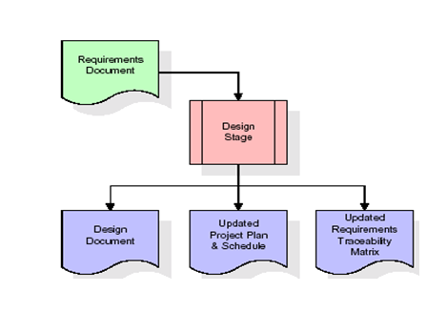
When the design document is finalized and accepted, the RTM is updated to show that each design element is formally associated with a specific requirement. The outputs of the design stage are the design document, an updated RTM, and an updated project plan.
Development (Coding) Stage:
The development stage takes as its primary input the design elements described in the approved design document. For each design element, a set of one or more software artifacts will be produced. Software artifacts include but are not limited to menus, dialogs, and data management forms, data reporting formats, and specialized procedures and functions. Appropriate test cases will be developed for each set of functionally related software artifacts, and an online help system will be developed to guide users in their interactions with the software.
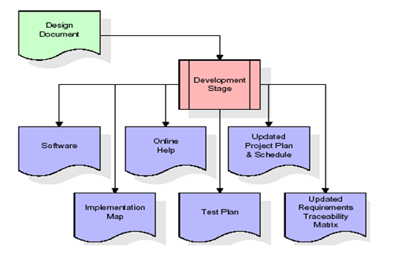
The RTM will be updated to show that each developed artifact is linked to a specific design element, and that each developed artifact has one or more corresponding test case items. At this point, the RTM is in its final configuration. The outputs of the development stage include a fully functional set of software that satisfies the requirements and design elements previously documented, an online help system that describes the operation of the software, an implementation map that identifies the primary code entry points for all major system functions, a test plan that describes the test cases to be used to validate the correctness and completeness of the software, an updated RTM, and an updated project plan.
Integration & Test Stage:
During the integration and test stage, the software artifacts, online help, and test data are migrated from the development environment to a separate test environment. At this point, all test cases are run to verify the correctness and completeness of the software. Successful execution of the test suite confirms a robust and complete migration capability. During this stage, reference data is finalized for production use and production users are identified and linked to their appropriate roles. The final reference data (or links to reference data source files) and production user list are compiled into the Production Initiation Plan.

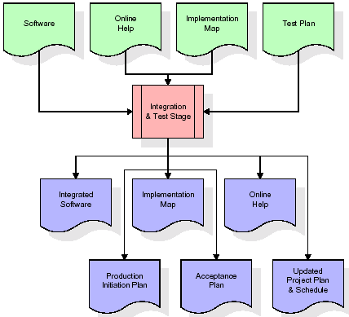
The outputs of the integration and test stage include an integrated set of software, an online help system, an implementation map, a production initiation plan that describes reference data and production users, an acceptance plan which contains the final suite of test cases, and an updated project plan.
- Installation & Acceptance Test:
During the installation and acceptance stage, the software artifacts, online help, and initial production data are loaded onto the production server. At this point, all test cases are run to verify the correctness and completeness of the software. Successful execution of the test suite is a prerequisite to acceptance of the software by the customer.
After customer personnel have verified that the initial production data load is correct and the test suite has been executed with satisfactory results, the customer formally accepts the delivery of the software.

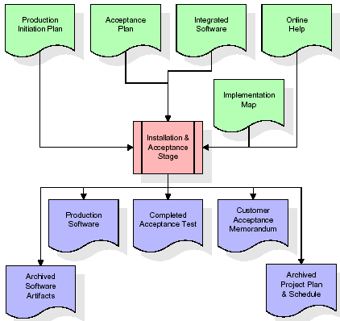

The primary outputs of the installation and acceptance stage include a production application, a completed acceptance test suite, and a memorandum of customer acceptance of the software. Finally, the PDR enters the last of the actual labor data into the project schedule and locks the project as a permanent project record. At this point the PDR "locks" the project by archiving all software items, the implementation map, the source code, and the documentation for future reference.
Maintenance:
Outer rectangle represents maintenance of a project, Maintenance team will start with requirement study, understanding of documentation later employees will be assigned work and they will undergo training on that particular assigned category. For this life cycle there is no end, it will be continued so on like an umbrella (no ending point to umbrella sticks).
3.4. Software Requirement Specification
3.4.1. Overall Description
A Software Requirements Specification (SRS) – a requirements specification for a software system is a complete description of the behavior of a system to be developed. It includes a set of use cases that describe all the interactions the users will have with the software. In addition to use cases, the SRS also contains non-functional requirements. Nonfunctional requirements are requirements which impose constraints on the design or implementation (such as performance engineering requirements, quality standards, or design constraints).
System requirements specification: A structured collection of information that embodies the requirements of a system. A business analyst, sometimes titled system analyst, is responsible for analyzing the business needs of their clients and stakeholders to help identify business problems and propose solutions. Within the systems development lifecycle domain, the BA typically performs a liaison function between the business side of an enterprise and the information technology department or external service providers. Projects are subject to three sorts of requirements:
- Business requirements describe in business terms what must be delivered or accomplished to provide value.
- Product requirements describe properties of a system or product (which could be one of several ways to accomplish a set of business requirements.)
- Process requirements describe activities performed by the developing organization. For instance, process requirements could specify .Preliminary investigation examine project feasibility, the likelihood the system will be useful to the organization. The main objective of the feasibility study is to test the Technical, Operational and Economical feasibility for adding new modules and debugging old running system. All system is feasible if they are unlimited resources and infinite time. There are aspects in the feasibility study portion of the preliminary investigation:

- ECONOMIC FEASIBILITY
A system can be developed technically and that will be used if installed must still be a good investment for the organization. In the economical feasibility, the development cost in creating the system is evaluated against the ultimate benefit derived from the new systems. Financial benefits must equal or exceed the costs. The system is economically feasible. It does not require any addition hardware or software. Since the interface for this system is developed using the existing resources and technologies available at NIC, There is nominal expenditure and economical feasibility for certain.
- Operational Feasibility
Proposed projects are beneficial only if they can be turned out into information system. That will meet the organization’s operating requirements. Operational feasibility aspects of the project are to be taken as an important part of the project implementation. This system is targeted to be in accordance with the above-mentioned issues. Beforehand, the management issues and user requirements have been taken into consideration. So there is no question of resistance from the users that can undermine the possible application benefits. The well-planned design would
Ensure the optimal utilization of the computer resources and would help in the improvement of performance status.
- TECHNICAL FEASIBILITY
Earlier no system existed to cater to the needs of ‘Secure Infrastructure Implementation System’. The current system developed is technically feasible. It is a web based user interface for audit workflow at NIC-CSD. Thus it provides an easy access to .the users. The database’s purpose is to create, establish and maintain a workflow among various entities in order to facilitate all concerned users in their various capacities or roles. Permission to the users would be granted based on the roles specified. Therefore, it provides the technical guarantee of accuracy, reliability and security.
3.4.2. External Interface Requirements
User Interface
The user interface of this system is a user-friendly python Graphical User Interface.
Hardware Interfaces
The interaction between the user and the console is achieved through python capabilities.
Software Interfaces
The required software is python.
SYSTEM REQUIREMENT:
HARDWARE REQUIREMENTS:

Processor - Intel i3(min)
- Speed - 1.1 GHz
- RAM - 4GB (min)
- Hard Disk - 500 GB
SOFTWARE REQUIREMENTS:
- Operating System - Windows10(min)
- Programming Language - Python (3.7.0)

4. SYSTEM DESIGN
UML Diagram:
Class Diagram:
The class diagram is the main building block of object oriented modeling. It is used both for general conceptual modeling of the systematic of the application, and for detailed modeling translating the models into programming code. Class diagrams can also be used for data modeling. The classes in a class diagram represent both the main objects, interactions in the application and the classes to be programmed. In the diagram, classes are represented with boxes which contain three parts:
- The upper part holds the name of the class
- The middle part contains the attributes of the class
- The bottom part gives the methods or operations the class can take or undertake.

Use case Diagram:
A use case diagram at its simplest is a representation of a user's interaction with the system and depicting the specifications of a use case. A use case diagram can portray the different types of users of a system and the various ways that they interact with the system. This type of diagram is typically used in conjunction with the textual use case and will often be accompanied by other types of diagrams as well.

Sequence Diagram:
A sequence diagram is a kind of interaction diagram that shows how processes operate with one another and in what order. It is a construct of a Message Sequence Chart. A sequence diagram shows object interactions arranged in time sequence. It depicts the objects and classes involved in the scenario and the sequence of messages exchanged between the objects needed to carry out the functionality of the scenario. Sequence diagrams are typically associated with use case realizations in the Logical View of the system under development. Sequence diagrams are sometimes called event diagrams, event scenarios, and timing diagrams.

Collaboration diagram:
A collaboration diagram describes interactions among objects in terms of sequenced messages. Collaboration diagrams represent a combination of information taken from class, sequence, and use case diagrams describing both the static structure and dynamic behavior of a system.

Component Diagram:
In the Unified Modeling Language, a component diagram depicts how components are wired together to form larger components and or software systems. They are used to illustrate the structure of arbitrarily complex systems.
Components are wired together by using an assembly connector to connect the required interface of one component with the provided interface of another component. This illustrates the service consumer - service provider relationship between the two components.
Deployment Diagram:
A deployment diagram in the Unified Modeling Language models the physical deployment of artifacts on nodes. To describe a web site, for example, a deployment diagram would show what hardware components ("nodes") exist (e.g., a web server, an application server, and a database server), what software components ("artifacts") run on each node (e.g., web application, database), and how the different pieces are connected (e.g. JDBC, REST, RMI).
The nodes appear as boxes, and the artifacts allocated to each node appear as rectangles within the boxes. Nodes may have sub nodes, which appear as nested boxes. A single node in a deployment diagram may conceptually represent multiple physical nodes, such as a cluster of database servers.

Activity Diagram:
Activity diagram is another important diagram in UML to describe dynamic aspects of the system. It is basically a flow chart to represent the flow form one activity to another activity. The activity can be described as an operation of the system. So the control flow is drawn from one operation to another. This flow can be sequential, branched or concurrent.

Index

Login

Register

Add Product

Update Tracing Action

Data Flow Diagram:
Data flow diagrams illustrate how data is processed by a system in terms of inputs and outputs. Data flow diagrams can be used to provide a clear representation of any business function. The technique starts with an overall picture of the business and continues by analyzing each of the functional areas of interest. This analysis can be carried out in precisely the level of detail required. The technique exploits a method called top-down expansion to conduct the analysis in a targeted way.
As the name suggests, Data Flow Diagram (DFD) is an illustration that explicates the passage of information in a process. A DFD can be easily drawn using simple symbols. Additionally, complicated processes can be easily automated by creating DFDs using easy-to-use, free downloadable diagramming tools. A DFD is a model for constructing and analyzing information processes. DFD illustrates the flow of information in a process depending upon the inputs and outputs. A DFD can also be referred to as a Process Model. A DFD demonstrates business or technical process with the support of the outside data saved, plus the data flowing from the process to another and the end results.

User

1. Index 2. Successfully Index
3. Login 4. Successfully Login
5. Register 6. Successfully Register
7. Add Product 8. Successfully Add Product
9. Update Tracing Action 10. Successfully Update Tracing Action

System

5. IMPLEMETATION
5.1 PYTHON
* One of the most popular languages is Python. Guido van Rossum released this language in 1991. Python is available on the Mac, Windows, and Raspberry Pi operating systems. The syntax of Python is simple and identical to that of English. When compared to Python, it was seen that the other language requires a few extra lines.
*It is an interpreter-based language because code may be run line by line after it has been written. This implies that rapid prototyping is possible across all platforms. Python is a big language with a free, binary-distributed interpreter standard library.
* It is inferior to maintenance that is conducted and is straightforward to learn. It is an object-oriented, interpreted programming language. It supports several different programming paradigms in addition to object-oriented programming, including functional and procedural programming.
* It supports several different programming paradigms in addition to object-oriented programming, including practical and procedural programming. Python is mighty while maintaining a relatively straightforward syntax. Classes, highly dynamic data types, modules, and exceptions are covered. Python can also be utilised by programmes that require programmable interfaces as an external language.
Here are some key features and characteristics of Python:
- Readability: Python emphasizes code readability with its clean and intuitive syntax. It uses indentation and whitespace to structure code blocks, making it easy to understand and maintain.
- Easy to Learn: Python's simplicity and readability make it an excellent choice for beginners. Its straightforward syntax and extensive documentation make it accessible for newcomers to programming.
- Interpreted Language: Python is an interpreted language, meaning that it doesn't need to be compiled before running. The Python interpreter reads and executes the code directly, making the development process faster and more interactive.
- Cross-platform Compatibility: Python is available for major operating systems like Windows, macOS, and Linux. This cross-platform compatibility allows developers to write code once and run it on different platforms without modifications.
- Large Standard Library: Python comes with a vast standard library that provides ready-to-use modules and functions for various tasks. It covers areas such as file I/O, networking, regular expressions, databases, and more, saving developers time and effort.
- Extensible and Modular: Python supports modular programming, enabling developers to organize code into reusable modules and packages. Additionally, Python allows integrating modules written in other languages, such as C or C++, providing flexibility and performance optimizations.
- Wide Range of Libraries and Frameworks: Python has a vibrant ecosystem with numerous third-party libraries and frameworks. These libraries, such as NumPy, pandas, TensorFlow, and Django, extend Python's capabilities for specific domains, making it a powerful tool for diverse applications.
- Object-Oriented: Python supports object-oriented programming (OOP) principles, allowing developers to create and work with classes and objects. OOP provides a structured approach to code organization, promoting code reuse and modularity.
- Dynamic Typing: Python is dynamically typed, meaning variable types are determined at runtime. Developers do not need to declare variable types explicitly, which enhances flexibility and simplifies code writing.
5.2 Installation
To install Python on your computer, follow these basic steps:
- Step 1: Visit the Python website Go to the official Python website at https://www.python.org/.
- Step 2: Select the operating system Choose the appropriate installer for your operating system. Python supports Windows, macOS, and various Linux distributions. Make sure to select the correct version that matches your operating system.
- Step 3: Check which version of Python is installed; if the 3.7.0 version is not there, uninstall it through the control panel and
- Step 4: Install Python 3.7.0 using Cmd.
- Step 5: Install the all libraries that required to run the project
- Step 6: Run
5.3 Python Features:
- Easy: Because Python is a more accessible and straightforward language, Python programming is easier to learn.
- Interpreted language: Python is an interpreted language, therefore it can be used to examine the code line by line and provide results.
- Open Source: Python is a free online programming language since it is open-source.
- Portable: Python is portable because the same code may be used on several computer standard
- libraries: Python offers a sizable library that we may utilize to create applications quickly.
- GUI: It stands for GUI (Graphical User Interface)
- Dynamical typed: Python is a dynamically typed language, therefore the type of the value will be determined at runtime.
5.4 Python GUI (Tkinter)
- Python provides a wide range of options for GUI development (Graphical User Interfaces).
- Tkinter, the most widely used GUI technique, is used for all of them.
- The Tk GUI toolkit offered by Python is used with the conventional Python interface.
- Tkinter is the easiest and quickest way to write Python GUI programs.
- Using Tkinter, creating a GUI is simple.
- A part of Python's built-in library is Tkinter. The GUI programs were created.
- Python and Tkinter together give a straightforward and quick way. The Tk GUI toolkit's object-oriented user interface is called Tkinter.

Making a GUI application is easy using Tkinter. Following are the steps:
1) Install the Tkinter module in place.
2) The GUI applicatioMakeske the primary window
3) Include one or more of the widgets mentioned above in the GUI application.
4) Set up the main event loop such that it reacts to each user-initiated event.
Although Tkinter is the only GUI framework included in the Python standard library, Python includes a GUI framework. The default library for Python is called Tkinter. Tk is a scripting language often used in designing, testing, and developing GUIs. Tk is a free, open-source widget toolkit that may be used to build GUI applications in a wide range of computer languages.
5.5 Python IDLE
- Python IDLE offers a full-fledged file editor, which gives you the ability to write and execute Python programs from within this program. The built-in file editor also includes several features, like code completion and automatic indentation, that will speed up your coding workflow.
- Guido Van Rossum named Python after the British comedy group Monty Python while the name IDLE was chosen to pay tribute to Eric Idle, who was one of the Monty Python's founding members. IDLE comes bundled with the default implementation of the Python language since the 01.5. 2b1 release
- IDLE is used to execute statements similar to Python Shell. IDLE is used to create, modify, and execute Python code. IDLE provides a fully-featured text editor to write Python scripts and provides features like syntax highlighting, auto-completion, and smart indent.
- IDLE has two modes: interactive and script. We wrote our first program, “Hello, World!” in interactive mode. Interactive mode immediately returns the results of commands you enter into the shell. In script mode, you will write a script and then run it.
- The IDE Python IDLE is a good place to start as it helps you become familiar with the way Python works and understand its syntax. This IDE is good to start programming in Python due to its great debugger, but once you are fluent and start developing projects it is necessary to jump to another, more complete IDE.
- Python IDLE (Integrated Development and Learning Environment) is an interactive development environment included with the Python programming language. It provides a convenient way to write, execute, and debug Python code.
When you install Python, IDLE is typically installed along with it. To open IDLE, you can follow these steps:
- Open the command prompt (Windows) or terminal (macOS/Linux).
- Type "idle" and press Enter. Alternatively, you can specify the version with "idle3" or "idle2" for Python 3 or Python 2, respectively.
- Once IDLE is launched, you will see the Python shell, which is an interactive environment where you can type and execute Python code directly.
Here are some features and functionalities provided by Python IDLE:
- Editor: IDLE includes a text editor where you can write your Python code. It offers syntax highlighting, automatic indentation, and code completion to enhance your coding experience.
- Interactive Shell: The Python shell in IDLE allows you to execute Python code interactively. You can type commands, statements, or function calls directly in the shell, and Python will execute them immediately.
- Debugging: IDLE provides basic debugging capabilities to help you find and fix errors in your code. You can set breakpoints, step through code, inspect variables, and track the program's execution.
- Python Help: IDLE provides access to the Python documentation and built-in help. You can access the help menu to find information about Python modules, functions, classes, and more.
- Script Execution: In addition to the interactive shell, IDLE allows you to run Python scripts stored in files. You can write your code in the editor and execute it as a script to see the output or interact with the program.
- Customization: IDLE can be customized to suit your preferences. You can modify settings related to syntax highlighting, indentation, fonts, and more.
- Python IDLE serves as a beginner-friendly development environment and learning tool. It is suitable for writing small scripts, testing code snippets, experimenting with Python features, and learning the language's basics. However, for more advanced development projects, you may consider using other code editors or integrated development environments (IDEs) that provide additional features and better project management capabilities.
5.6 Libraries
In Python, libraries (also referred to as modules or packages) are collections of pre-written code that provide additional functionality and tools to extend the capabilities of the Python language. Libraries contain reusable code that developers can leverage to perform specific tasks without having to write everything from scratch.
Python libraries are designed to solve common problems, such as handling data, performing mathematical operations, interacting with databases, working with files, implementing networking protocols, creating graphical user interfaces (GUIs), and much more. They provide ready-to-use functions, classes, and methods that simplify complex operations and save development time.
Libraries in Python offer various advantages:
- Code Reusability:
- Efficiency:
- Collaboration
- Domain-Specific Functionality
- To use a Python library, you need to install it first.
There are some libraries following:
- Pandas:
Pandas are a Python computer language library for data analysis and manipulation. It offers a specific operation and data format for handling time series and numerical tables. It differs significantly from the release3-clause of the BSD license. It is a well-liked open-source of opinion that is utilized in machine learning and data analysis.
Pandas are a Python package providing fast, flexible, and expressive data structures designed to make working with “relational” or “labeled” data both easy and intuitive. It aims to be the fundamental high-level building block for doing practical, real-world data analysis in Python. Pandas are a Python library used for working with data sets.
- It has functions for analysing, cleaning, exploring, and manipulating data.
- The name "Pandas" has a reference to both "Panel Data", and "Python Data Analysis" and was created by Wes McKinney in 2008.
- Pandas allow us to analyse big data and make conclusions based on statistical theories.
- Pandas can clean messy data sets, and make them readable and relevant.
Relevant data is very important in data science. Pandas are a Python library for data analysis. Started by Wes McKinney in 2008 out of a need for a powerful and flexible quantitative analysis tool, pandas have grown into one of the most popular Python libraries. It has an extremely active community of contributors. The name is derived from the term "panel data", an econometrics term for data sets that include observations over multiple time periods for the same individuals. Its name is a play on the phrase "Python data analysis" itself.
- NumPy:
The NumPy Python library for multi-dimensional, big-scale matrices adds a huge number of high-level mathematical functions. It is possible to modify NumPy by utilizing a Python library. Along with line, algebra, and the Fourier transform operations, it also contains several matrices-related functions.
NumPy can be used to perform a wide variety of mathematical operations on arrays. It adds powerful data structures to Python that guarantee efficient calculations with arrays and matrices and it supplies an enormous library of high-level mathematical functions that operate on these arrays and matrices.
- NumPy is a Python library used for working with arrays.
- It also has functions for working in domain of linear algebra, Fourier transform, and matrices.
- NumPy was created in 2005 by Travis Oliphant. It is an open source project and you can use it freely.
- NumPy stands for Numerical Python.
- In Python we have lists that serve the purpose of arrays, but they are slow to process.
- NumPy aims to provide an array object that is up to 50x faster than traditional Python lists.
- The array object in NumPy is called ndarray, it provides a lot of supporting functions that make working with ndarray very easy.
- Arrays are very frequently used in data science, where speed and resources are very important.

- Matplotlib:
It is a multi-platform, array-based data visualization framework built to interact with the whole SciPy stack. MATLAB is proposed as an open-source alternative. Matplotlib is a Python extension and a cross-platform toolkit for graphical plotting and visualization.
Matplotlib is a popular Python library for creating static, animated, and interactive visualizations. It provides a flexible and comprehensive set of tools for generating plots, charts, histograms, scatter plots, and more. Matplotlib is widely used in various fields, including data analysis, scientific research, and data visualization.
Here are some key features and functionalities of the Matplotlib library:
- Plotting Functions
- Customization Options
- Multiple Interfaces
- Integration with NumPy and pandas
- Subplots and Figures:
- Saving and Exporting

- Scikit-learn:
The most stable and practical machine learning library for Python is scikit-learn. Regression, dimensionality reduction, classification, and clustering are just a few of the helpful tools it provides through the Python interface for statistical modeling and machine learning. It is an essential part of the Python machine learning toolbox used by JP Morgan. It is frequently used in various machine learning applications, including classification and predictive analysis.
Scikit-learn (also referred to as sklearn) is a widely used open-source machine learning library for Python. It provides a comprehensive set of tools and algorithms for various machine learning tasks, including classification, regression, clustering, dimensionality reduction, model selection, and pre-processing.
Here are some key features and functionalities of the Scikit-learn library:
- Easy-to-Use Interface:
- Broad Range of Algorithms:
- Data Pre-processing and Feature Engineering:
- Model Evaluation and Validation:
- Integration with NumPy and pandas:
- Robust Documentation and Community Support:

- Keras:
* Google's Keras is a cutting-edge deep learning API for creating neural networks. It is created in Python and is designed to simplify the development of neural networks. Additionally, it enables the use of various neural networks for computation. Deep learning models are developed and tested using the free and open-source Python software known as Keras.
Keras is a high-level deep learning library for Python. It is designed to provide a user-friendly and intuitive interface for building and training deep learning models. Keras acts as a front-end API, allowing developers to define and configure neural networks while leveraging the computational backend engines, such as Tensor Flow or Theano.
Here are some key features and functionalities of the Keras library:
- User-Friendly API
- Multi-backend Support
- Wide Range of Neural Network Architectures
- Pre-trained Models and Transfer Learning:
- Easy Model Training and Evaluation:
- GPU Support:

- h5py:
* The h5py Python module offers an interface for the binary HDF5 data format. Thanks to p5py, the top can quickly halt the vast amount of numerical data and alter it using the NumPy library. It employs common syntax for Python, NumPy, and dictionary arrays.
h5py is a Python library that provides a simple and efficient interface for working with datasets and files in the Hierarchical Data Format 5 (HDF5) format. HDF5 is a versatile data format commonly used for storing and managing large volumes of numerical data.
Here are some key features and functionalities of the h5py library:
  - HDF5 File Access
  - Dataset Handling:
  - Group Organization:
  - Attributes:
  - Compatibility with NumPy
  - Performance

- Tensor flow
TensorFlow is a Python library for fast numerical computing created and released by Google. It is a foundation library that can be used to create Deep Learning models directly or by using wrapper libraries that simplify the process built on top of TensorFlow. TensorFlow is an end-to-end open source platform for machine learning. TensorFlow is a rich system for managing all aspects of a machine learning system; however, this class focuses on using a particular TensorFlow API to develop and train machine learning models.
TensorFlow is a popular open-source library for machine learning and deep learning. It provides a comprehensive set of tools, APIs, and computational resources for building and training various types of machine learning models, especially neural networks.
Here are some key features and functionalities of TensorFlow:
- Neural Network Framework:
- Computational Graphs
- Automatic Differentiation
- GPU and TPU Support
- Distributed Computing
- Deployment Capabilities

- Tkinter
Tkinter is an acronym for "Tk interface". Tk was developed as a GUI extension for the Tcl scripting language by John Ousterhout. The first release was in 1991. Tkinter is the de facto way in Python to create Graphical User interfaces (GUIs) and is included in all standard Python Distributions. In fact, it's the only framework built into the Python standard library.
Tkinter is a standard Python library used for creating graphical user interfaces (GUIs). It provides a set of modules and classes that allow you to develop interactive and visually appealing desktop applications.
Here are some key features and functionalities of Tkinter:
- Cross-Platform Compatibility
- Simple and Easy-to-Use
- Widgets and Layout Management
- Event-Driven Programming
- Customization and Styling
- Integration with Other Libraries

- NLTK
NLTK is a toolkit build for working with NLP in Python. It provides us various text processing libraries with a lot of test datasets. A variety of tasks can be performed using NLTK such as tokenizing, parse tree visualization, etc NLTK (Natural Language Toolkit) is the go-to API for NLP (Natural Language Processing) with Python. It is a really powerful tool to pre-process text data for further analysis like with ML models for instance. It helps convert text into numbers, which the model can then easily work with.
NLTK (Natural Language Toolkit) is a Python library widely used for working with human language data and implementing natural language processing (NLP) tasks. It provides a set of tools, corpora, and resources for tasks such as tokenization, stemming, tagging, parsing, sentiment analysis, and more.
Here are some key features and functionalities of NLTK:
- Text Processing
- Part-of-Speech Tagging
- Named Entity Recognition
- Chunking and Parsing
- Sentiment Analysis:
- WordNet Integration:

- Scipy
SciPy is a collection of mathematical algorithms and convenience functions built on the NumPy extension of Python. It adds significant power to the interactive Python session by providing the user with high-level commands and classes for manipulating and visualizing data.
SciPy is a powerful scientific computing library for Python that provides a wide range of mathematical algorithms and functions. It builds upon NumPy, another fundamental library for numerical computing, and extends its capabilities by adding additional tools for scientific and technical computing tasks.
Here are some key features and functionalities of SciPy:
- Numerical Integration:
- Optimization and Root Finding
- Linear Algebra
- Signal and Image Processing
- Statistics
5.2 Sample Code:
Views.py
from django.shortcuts import render
from django.template import RequestContext
from django.contrib import messages
import pymysql
from django.http import HttpResponse
from django.core.files.storage import FileSystemStorage
import os
from datetime import date
import os
import json
from web3 import Web3, HTTPProvider
import os
from django.core.files.storage import FileSystemStorage
import pickle

global details, username
details=''
global contract, product_name

def readDetails(contract_type):
global details
details = ""
print(contract_type+"======================")
blockchain_address = 'http://127.0.0.1:9545' #Blokchain connection IP
web3 = Web3(HTTPProvider(blockchain_address))
web3.eth.defaultAccount = web3.eth.accounts[0]
compiled_contract_path = 'Drug.json' #Drug contract code
deployed_contract_address = '0x1DD4fb45C1cdC8C3f32cbaA60464c8107D4D4058' #hash address to access Drug contract
with open(compiled_contract_path) as file:
contract_json = json.load(file) # load contract info as JSON
contract_abi = contract_json['abi'] # fetch contract's abi - necessary to call its functions
file.close()
contract = web3.eth.contract(address=deployed_contract_address, abi=contract_abi) #now calling contract to access data
if contract_type == 'signup':
details = contract.functions.getUser().call()
if contract_type == 'addproduct':
details = contract.functions.getTracingData().call()
print(details)

def saveDataBlockChain(currentData, contract_type):
global details
global contract
details = ""
blockchain_address = 'http://127.0.0.1:9545'
web3 = Web3(HTTPProvider(blockchain_address))
web3.eth.defaultAccount = web3.eth.accounts[0]
compiled_contract_path = 'Drug.json' #Drug contract file
deployed_contract_address = '0x1DD4fb45C1cdC8C3f32cbaA60464c8107D4D4058' #contract address
with open(compiled_contract_path) as file:
contract_json = json.load(file) # load contract info as JSON
contract_abi = contract_json['abi'] # fetch contract's abi - necessary to call its functions
file.close()
contract = web3.eth.contract(address=deployed_contract_address, abi=contract_abi)
readDetails(contract_type)
if contract_type == 'signup':
details+=currentData
msg = contract.functions.addUser(details).transact()
tx_receipt = web3.eth.waitForTransactionReceipt(msg)
if contract_type == 'addproduct':
details+=currentData
msg = contract.functions.setTracingData(details).transact()
tx_receipt = web3.eth.waitForTransactionReceipt(msg)

def updateQuantityBlock(currentData):
blockchain_address = 'http://127.0.0.1:9545'
web3 = Web3(HTTPProvider(blockchain_address))
web3.eth.defaultAccount = web3.eth.accounts[0]
compiled_contract_path = 'Drug.json' #student contract file
deployed_contract_address = '0x1DD4fb45C1cdC8C3f32cbaA60464c8107D4D4058' #contract address
with open(compiled_contract_path) as file:
contract_json = json.load(file) # load contract info as JSON
contract_abi = contract_json['abi'] # fetch contract's abi - necessary to call its functions
file.close()
contract = web3.eth.contract(address=deployed_contract_address, abi=contract_abi)
msg = contract.functions.setTracingData(currentData).transact()
tx_receipt = web3.eth.waitForTransactionReceipt(msg)

def index(request):
if request.method == 'GET':
return render(request, 'index.html', {})

def Login(request):
if request.method == 'GET':
return render(request, 'Login.html', {})

def Register(request):
if request.method == 'GET':
return render(request, 'Register.html', {})

def AddProduct(request):
if request.method == 'GET':
return render(request, 'AddProduct.html', {})

def UpdateTracingAction(request):
if request.method == 'GET':
global product_name
product_name = request.GET['pname']
output = '<tr><td><font size="" color="black">Product&nbsp;Name</font></td>'
output += '<td><input type="text" name="t1" style="font-family: Comic Sans MS" size="30" value='+product_name+' readonly/></td></tr>'
context= {'data':output}
return render(request, 'AddTracing.html', context)

def UpdateTracing(request):
if request.method == 'GET':
output = '<table border=1 align=center>'
output+='<tr><th><font size=3 color=black>Drug Name</font></th>'
output+='<th><font size=3 color=black>Price</font></th>'
output+='<th><font size=3 color=black>Quantity</font></th>'
output+='<th><font size=3 color=black>Description</font></th>'
output+='<th><font size=3 color=black>Image</font></th>'
output+='<th><font size=3 color=black>Last Update Date</font></th>'
output+='<th><font size=3 color=black>Current Tracing Info</font></th>'
output+='<th><font size=3 color=black>Update New Tracing Info</font></th></tr>'
readDetails("addproduct")
rows = details.split("\n")
for i in range(len(rows)-1):
arr = rows[i].split("#")
if arr[0] == 'addproduct':
output+='<tr><td><font size=3 color=black>'+arr[1]+'</font></td>'
output+='<td><font size=3 color=black>'+arr[2]+'</font></td>'
output+='<td><font size=3 color=black>'+str(arr[3])+'</font></td>'
output+='<td><font size=3 color=black>'+str(arr[4])+'</font></td>'
output+='<td><img src="/static/products/'+arr[5]+'" width="200" height="200"></img></td>'
output+='<td><font size=3 color=black>'+str(arr[6])+'</font></td>'
output+='<td><font size=3 color=black>'+str(arr[7])+'</font></td>'
output+='<td><a href=\'UpdateTracingAction?pname='+arr[1]+'\'><font size=3 color=black>Click Here</font></a></td></tr>'
output+="</table><br/><br/><br/><br/><br/><br/>"
context= {'data':output}
return render(request, 'UpdateTracing.html', context)

def AddTracingAction(request):
if request.method == 'POST':
product_name = request.POST.get('t1', False)
tracing_type = request.POST.get('t2', False)
tracing_status = request.POST.get('t3', False)
index = 0
record = ''
readDetails("addproduct")
rows = details.split("\n")
tot_qty = 0
for i in range(len(rows)-1):
arr = rows[i].split("#")
if arr[0] == "addproduct":
if arr[1] == product_name:
today = date.today()
index = i
record = arr[0]+"#"+arr[1]+"#"+arr[2]+"#"+arr[3]+"#"+arr[4]+"#"+arr[5]+"#"+str(today)+"#"+tracing_type+"! "+tracing_status+"\n"
break
for i in range(len(rows)-1):
if i != index:
record += rows[i]+"\n"
updateQuantityBlock(record)
context= {'data':"Tracing details updated"}
return render(request, 'AdminScreen.html', context)

def AddProductAction(request):
if request.method == 'POST':
cname = request.POST.get('t1', False)
qty = request.POST.get('t2', False)
price = request.POST.get('t3', False)
desc = request.POST.get('t4', False)
image = request.FILES['t5']
imagename = request.FILES['t5'].name

today = date.today()
fs = FileSystemStorage()
filename = fs.save('DrugTraceApp/static/products/'+imagename, image)

data = "addproduct#"+cname+"#"+price+"#"+qty+"#"+desc+"#"+imagename+"#"+str(today)+"#Production State\n"
saveDataBlockChain(data,"addproduct")
context= {'data':"Product details saved in Blockchain"}
return render(request, 'AddProduct.html', context)

def Signup(request):
if request.method == 'POST':
username = request.POST.get('username', False)
password = request.POST.get('password', False)
contact = request.POST.get('contact', False)
email = request.POST.get('email', False)
address = request.POST.get('address', False)
record = 'none'
readDetails("signup")
rows = details.split("\n")
for i in range(len(rows)-1):
arr = rows[i].split("#")
if arr[0] == "signup":
if arr[1] == username:
record = "exists"
break
if record == 'none':
data = "signup#"+username+"#"+password+"#"+contact+"#"+email+"#"+address+"\n"
saveDataBlockChain(data,"signup")
context= {'data':'Signup process completd and record saved in Blockchain'}
return render(request, 'Register.html', context)
else:
context= {'data':username+'Username already exists'}
return render(request, 'Register.html', context)

def UserLogin(request):
if request.method == 'POST':
username = request.POST.get('username', False)
password = request.POST.get('password', False)
status = "Login.html"
context= {'data':'Invalid login details'}
if username == 'admin' and password == 'admin':
context = {'data':"Welcome "+username}
status = "AdminScreen.html"
else:
readDetails("signup")
rows = details.split("\n")
for i in range(len(rows)-1):
arr = rows[i].split("#")
if arr[0] == "signup":
if arr[1] == username and arr[2] == password:
context = {'data':"Welcome "+username}
status = 'UserScreen.html'
file = open('session.txt','w')
file.write(username)
file.close()
break
return render(request, status, context)

def ViewTracing(request):
if request.method == 'GET':
output = '<table border=1 align=center>'
output+='<tr><th><font size=3 color=black>Drug Name</font></th>'
output+='<th><font size=3 color=black>Price</font></th>'
output+='<th><font size=3 color=black>Quantity</font></th>'
output+='<th><font size=3 color=black>Description</font></th>'
output+='<th><font size=3 color=black>Image</font></th>'
output+='<th><font size=3 color=black>Last Update Date</font></th>'
output+='<th><font size=3 color=black>Current Tracing Info</font></th></tr>'

readDetails("addproduct")
rows = details.split("\n")
for i in range(len(rows)-1):
arr = rows[i].split("#")
if arr[0] == 'addproduct':
output+='<tr><td><font size=3 color=black>'+arr[1]+'</font></td>'
output+='<td><font size=3 color=black>'+arr[2]+'</font></td>'
output+='<td><font size=3 color=black>'+str(arr[3])+'</font></td>'
output+='<td><font size=3 color=black>'+str(arr[4])+'</font></td>'
output+='<td><img src="/static/products/'+arr[5]+'" width="200" height="200"></img></td>'
output+='<td><font size=3 color=black>'+str(arr[6])+'</font></td>'
output+='<td><font size=3 color=black>'+str(arr[7])+'</font></td>'
output+="</table><br/><br/><br/><br/><br/><br/>"
context= {'data':output}
return render(request, 'ViewTracing.html', context)
6. TESTING
Implementation and Testing:
Implementation is one of the most important tasks in project is the phase in which one has to be cautions because all the efforts undertaken during the project will be very interactive. Implementation is the most crucial stage in achieving successful system and giving the users confidence that the new system is workable and effective. Each program is tested individually at the time of development using the sample data and has verified that these programs link together in the way specified in the program specification. The computer system and its environment are tested to the satisfaction of the user.
Implementation
The implementation phase is less creative than system design. It is primarily concerned with user training, and file conversion. The system may be requiring extensive user training. The initial parameters of the system should be modifies as a result of a programming. A simple operating procedure is provided so that the user can understand the different functions clearly and quickly. The different reports can be obtained either on the inkjet or dot matrix printer, which is available at the disposal of the user. The proposed system is very easy to implement. In general implementation is used to mean the process of converting a new or revised system design into an operational one.

Testing
Testing is the process where the test data is prepared and is used for testing the modules individually and later the validation given for the fields. Then the system testing takes place which makes sure that all components of the system property functions as a unit. The test data should be chosen such that it passed through all possible condition. Actually testing is the state of implementation which aimed at ensuring that the system works accurately and efficiently before the actual operation commence. The following is the description of the testing strategies, which were carried out during the testing period.
System Testing
Testing has become an System integral part of any system or project especially in the field of information technology. The importance of testing is a method of justifying, if one is ready to move further, be it to be check if one is capable to with stand the rigors of a particular situation cannot be underplayed and that is why testing before development is so critical. When the software is developed before it is given to user to user the software must be tested whether it is solving the purpose for which it is developed. This testing involves various types through which one can ensure the software is reliable. The program was tested logically and pattern of execution of the program for a set of data are repeated. Thus the code was exhaustively checked for all possible correct data and the outcomes were also checked.
Module Testing
To locate errors, each module is tested individually. This enables us to detect error and correct it without affecting any other modules. Whenever the program is not satisfying the required function, it must be corrected to get the required result. Thus all the modules are individually tested from bottom up starting with the smallest and lowest modules and proceeding to the next level. Each module in the system is tested separately. For example the job classification module is tested separately. This module is tested with different job and its approximate execution time and the result of the test is compared with the results that are prepared manually. The comparison shows that the results proposed system works efficiently than the existing system. Each module in the system is tested separately. In this system the resource classification and job scheduling modules are tested separately and their corresponding results are obtained which reduces the process waiting time.
Integration Testing
After the module testing, the integration testing is applied. When linking the modules there may be chance for errors to occur, these errors are corrected by using this testing. In this system all modules are connected and tested. The testing results are very correct. Thus the mapping of jobs with resources is done correctly by the system.
Acceptance Testing
When that user fined no major problems with its accuracy the system passers through a final acceptance test. This test confirms that the system needs the original goals, objectives and requirements established during analysis without actual execution which elimination wastage of time and money acceptance tests on the shoulders of users and management, it is finally acceptable and ready for the operation.

Test  Case  ID | Test  case  Name | Test Case  Desc. | Step | Expected | Actual | Test  Case  Status | Test  Case  Priority
01 | Index | Verify The Index done or not | If The Index may not done | We cannot do the further operations | We Can do further operations | High | High
02 | Login | Verify the  Login done or not | If the  Login May Not be done | We cannot do the further operations | We Can do further operations | High | High
03 | Train Register | Verify The Register done or not | If The Register may not done | We cannot do the further operations | We Can do further operations | High | High
04 | Add Product | Verify The AddProduct done or not | If The AddProduct may not done | We cannot do the further operations | We Can do further operations | High | High
05 | Update Tracing Action | Verify Update Tracing Action done or not | If The Update Tracing Action may not done | We cannot do the further operations | We Can do further operations | High | High

7. SCREEN SHOTS:
To implement this Drug products tracing project we have used Blockchain Ethereum with Truffle environment and to store or retrieve data in Blockchain we need to design SOLIDITY (Smart Contract) code which will contains function to store and retrieve data. To implement this project we have designed below Solidity code
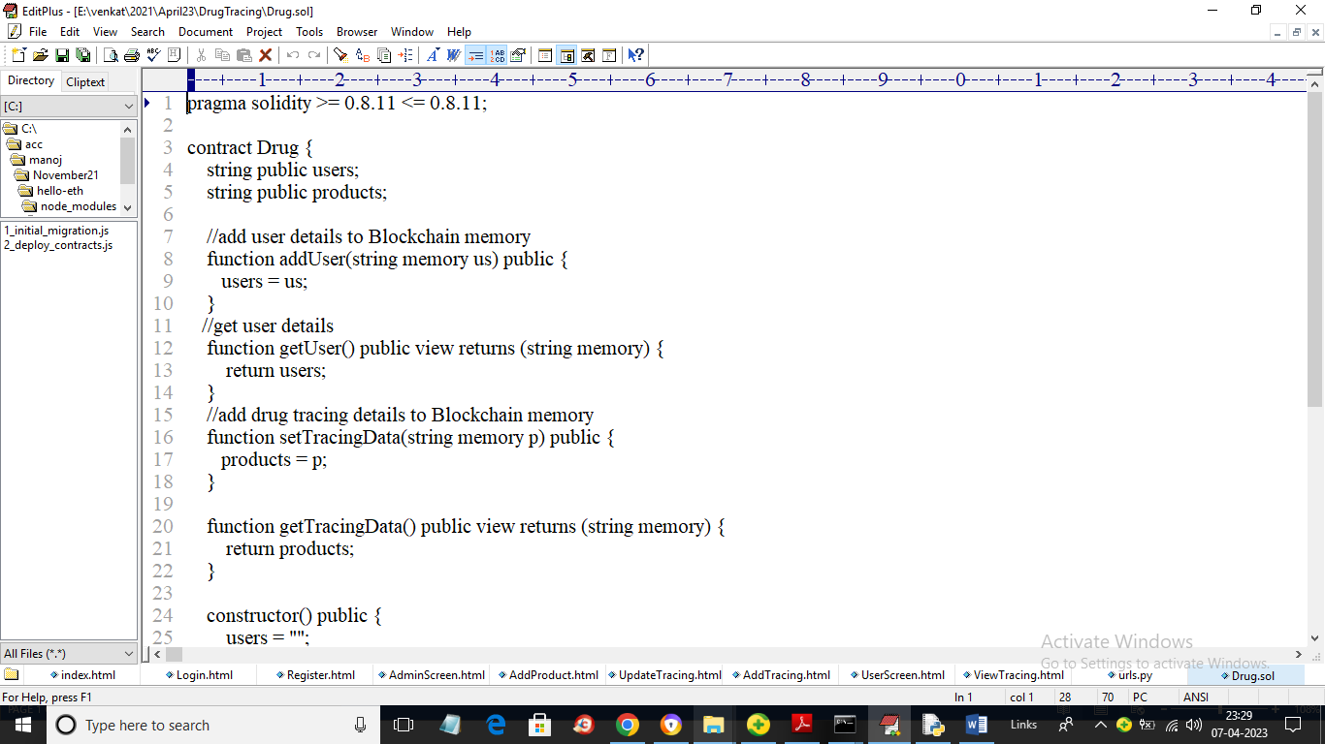
In above Solidity code also known as smart contract we have designed functions to store and retrieve USERS and Drug Tracing details. Now we need to deploy above contract in Ethereum by using below instructions
- Go inside ‘hello-eth/node_modules/.bin’ folder and then double click on ‘runBlockchain.bat’ file to get below screen
- 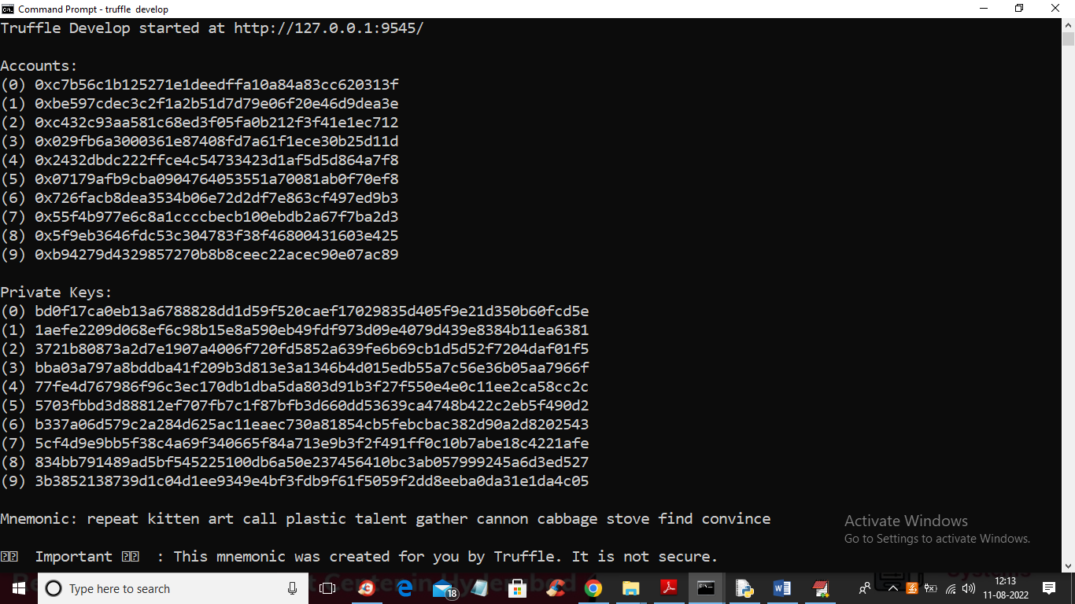
- In above screen we can see Blockchain created some default accounts and private keys and in above screen just type command as ‘truffle migrate’ and press enter key to deploy contract and get below output
- 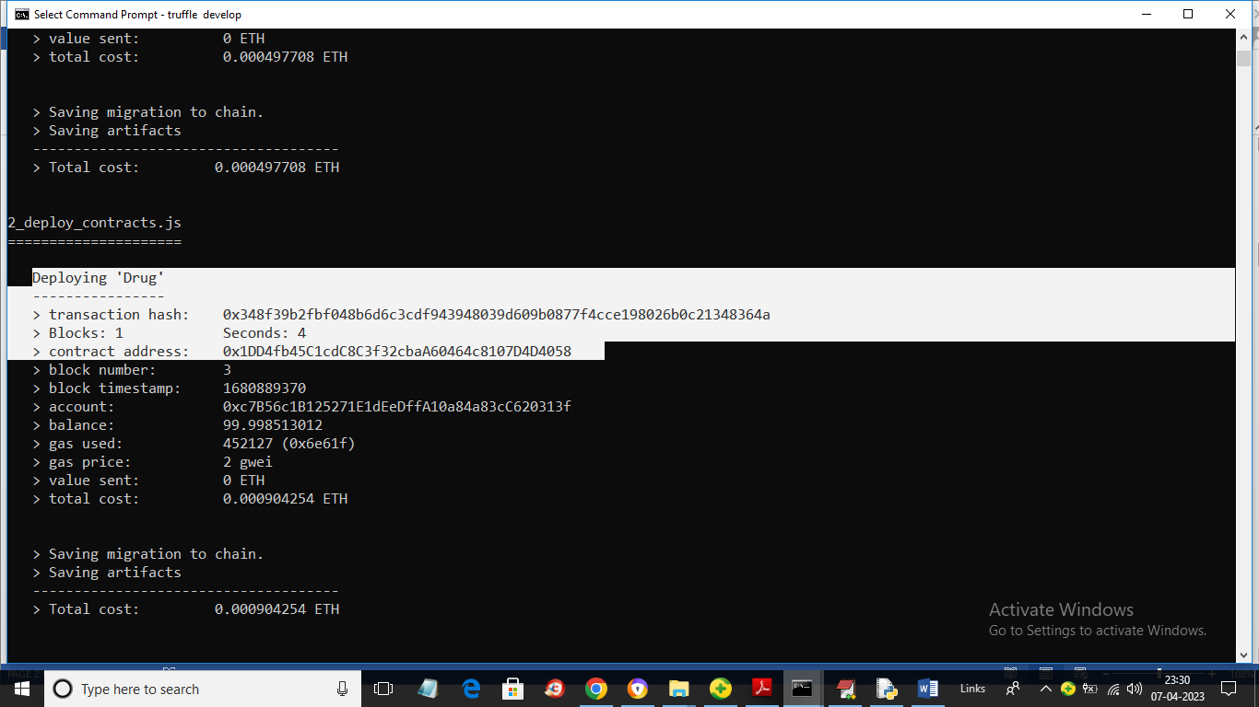
- In above screen in white colour text we can see ‘Drug’ contract deployed and we got contract address also and this address we need to specify in python program to store and retrieve TRACING details. In below screen I am showing python code to access Blockchain contract by using above contract address
- 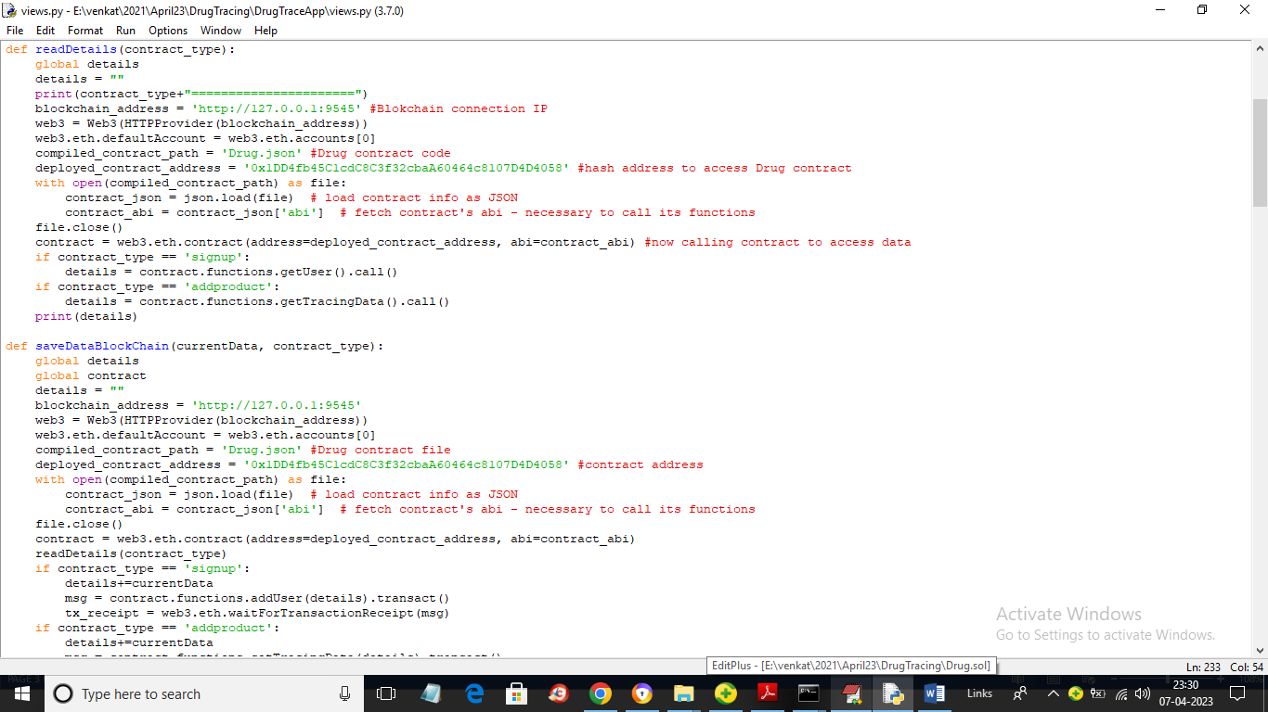
- In above screen read red colour comments to know about calling Blockchain contract to store and retrieve data using python program.
Modules Information
To implement this project we have designed 2 modules called Admin and User. Admin can login to application using username and password as ‘admin’. After login admin can add Drug details and then update tracing information.
User can signup and login and then can view current tracing information of Drugs. Users can be pharmacy, distributors, users or any other normal user.
Now contract and modules are ready and now we can run project
SCREEN SHOTS
To run project double click on ‘run.bat’ file to get below screen
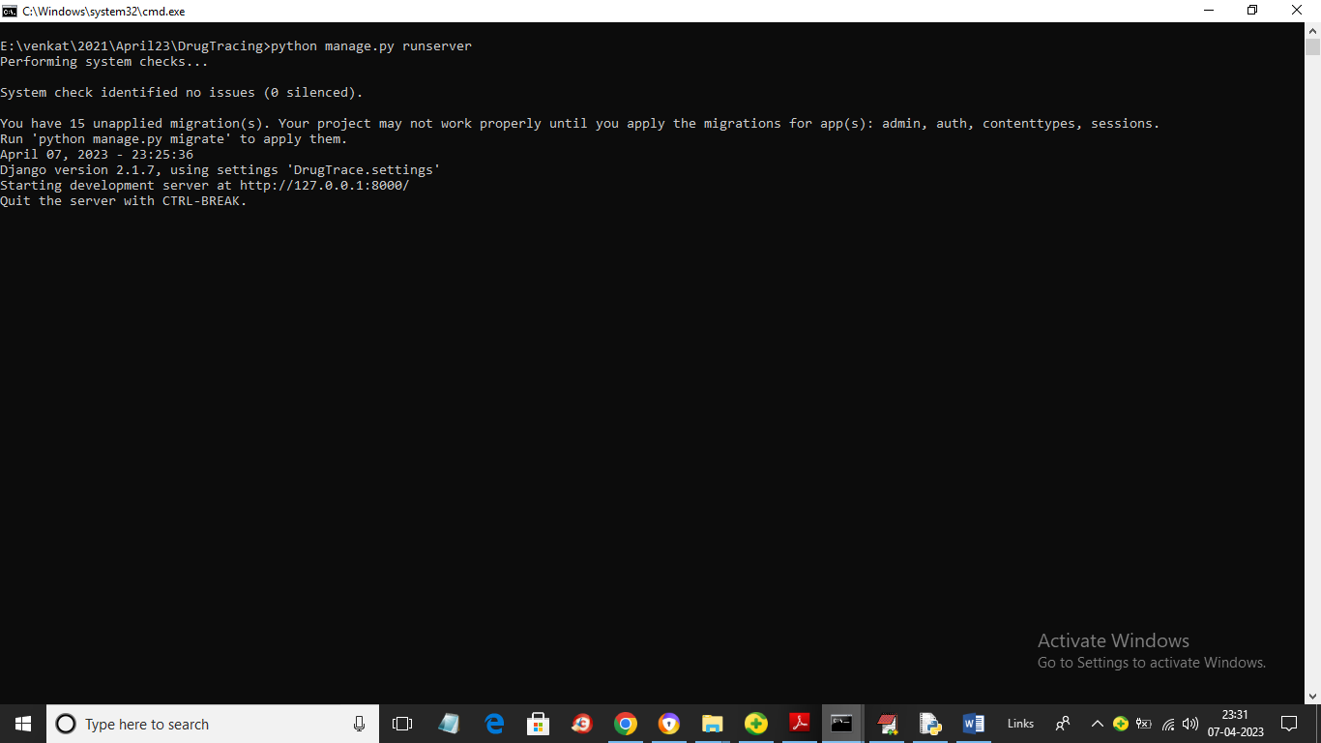
In above screen python server started and now open browser and enter URL as ‘http://127.0.0.1:8000/index.html’ and press enter key to get below home page
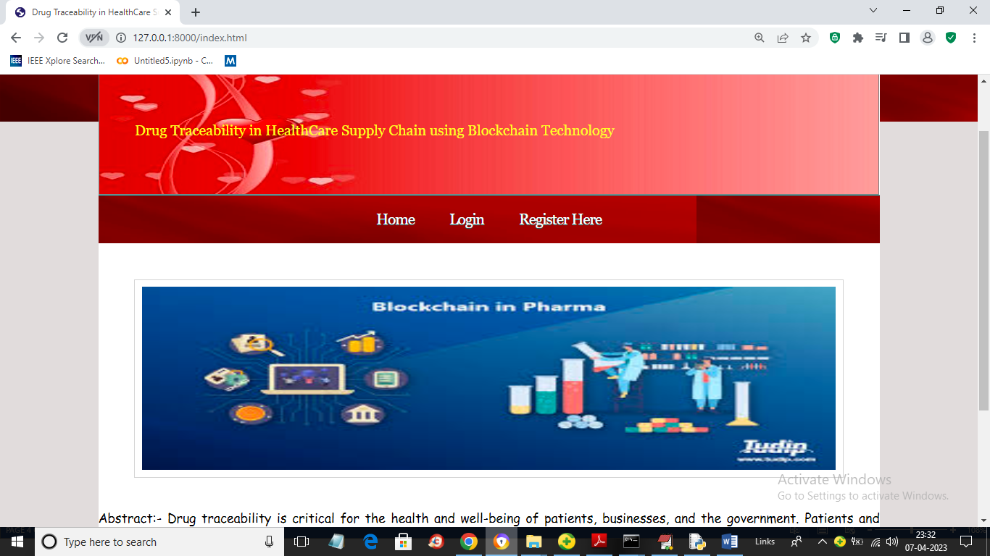
In above screen click on ‘Login’ link and login as admin
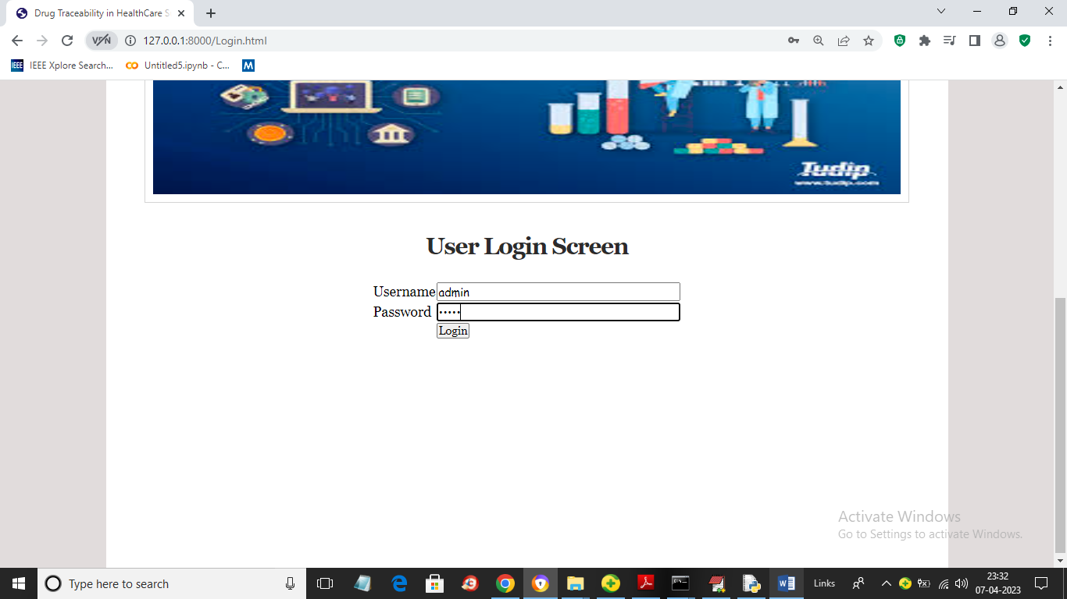
In above screen admin is login and after login will get below output
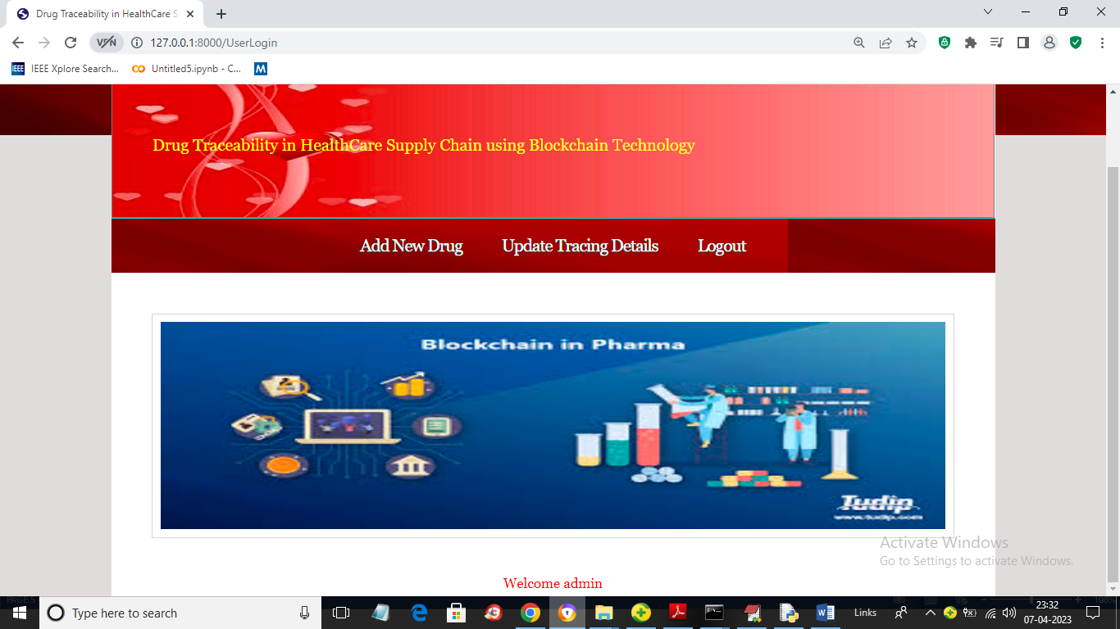
In above screen admin can click on ‘Add New Drug’ link to add new product details
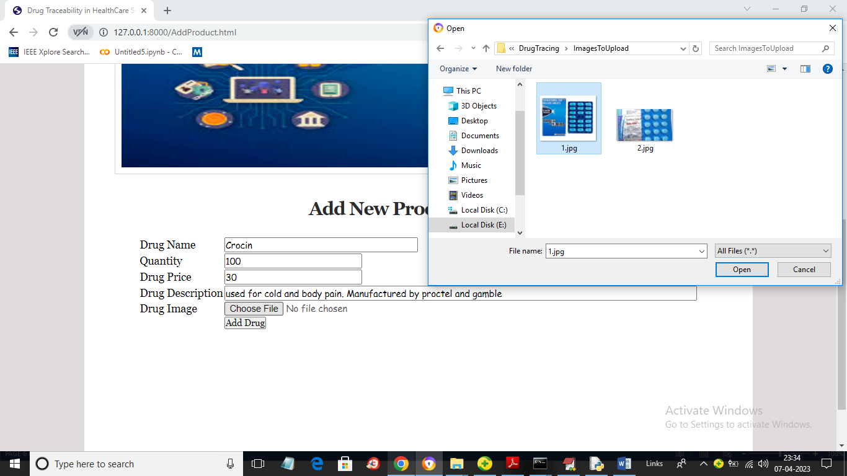
In above screen admin will add all Drug details and then upload image and then press ‘Add Drug’ button to get below output
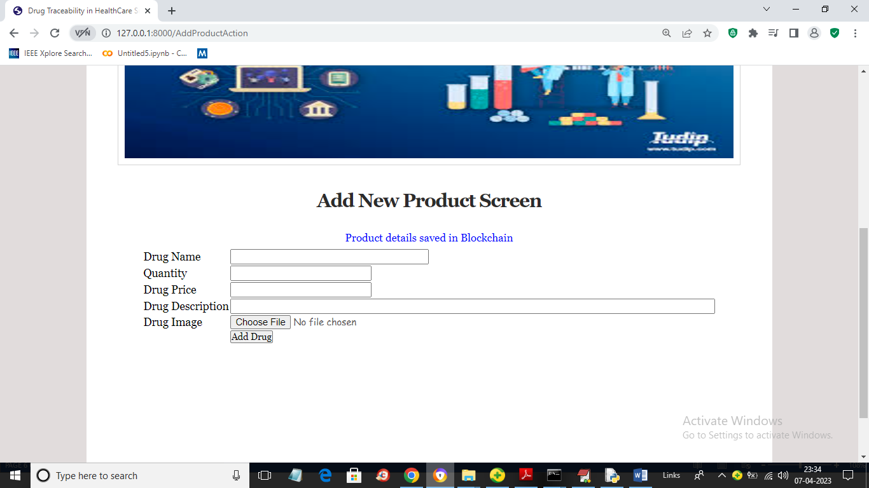
In above screen in blue colour text we can see Drug details added. Similarly you can add any number of drugs to Blockchain. now click on ‘Update Tracing Details’ link to get below output
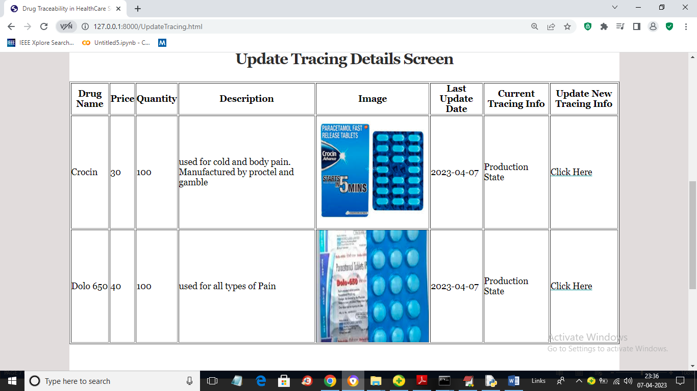
In above screen admin can view all Drug details and to update tracing details from current state, admin will click on ‘Click Here’ link to get below screen
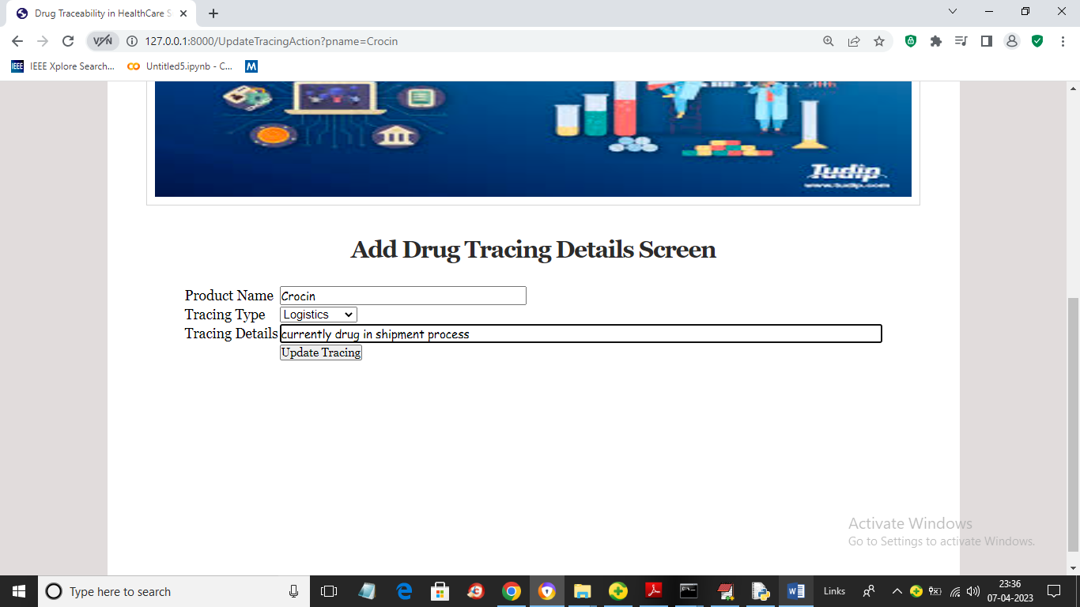
In above screen admin will select Tracing Type and then enter current tracing details and press button to store current tracing data to Blockchain and get below output
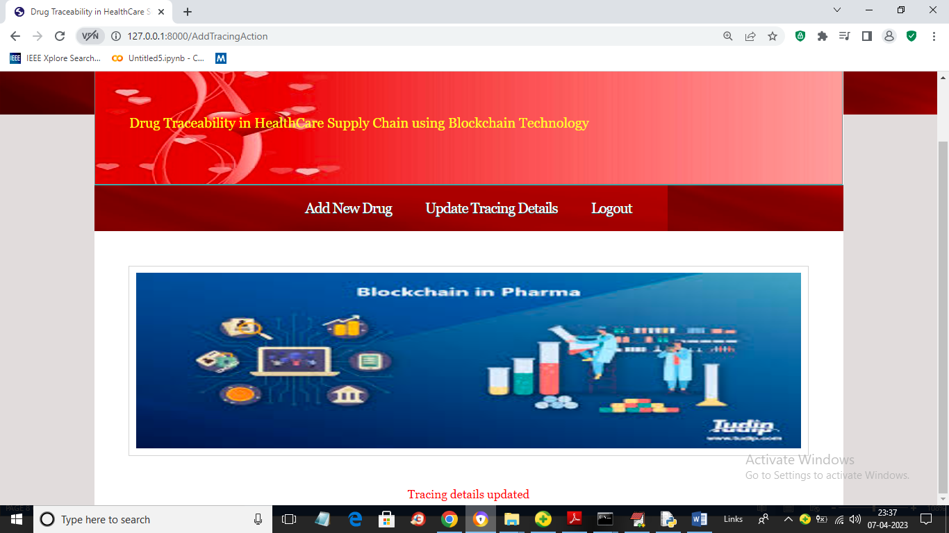
In above screen in red colour text we can see tracing details updated and all users can view this updated trace details. Now logout and signup new user
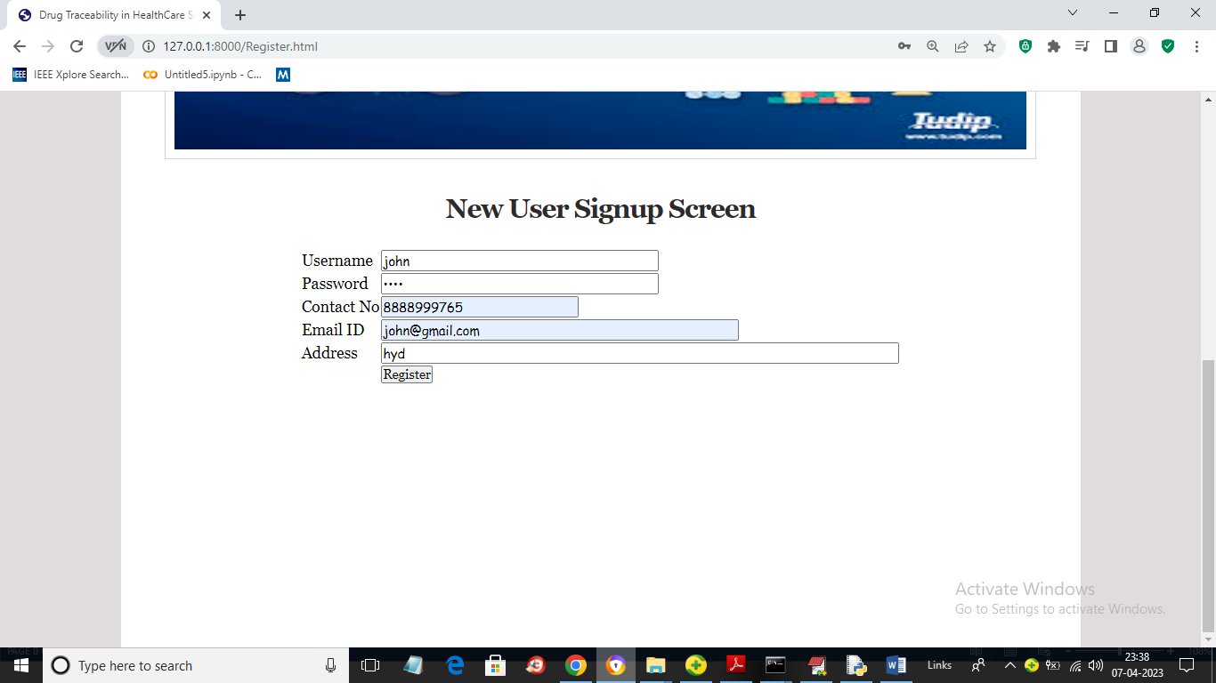
In above screen user is entering signup details and then press button to store user data to Blockchain and get below output
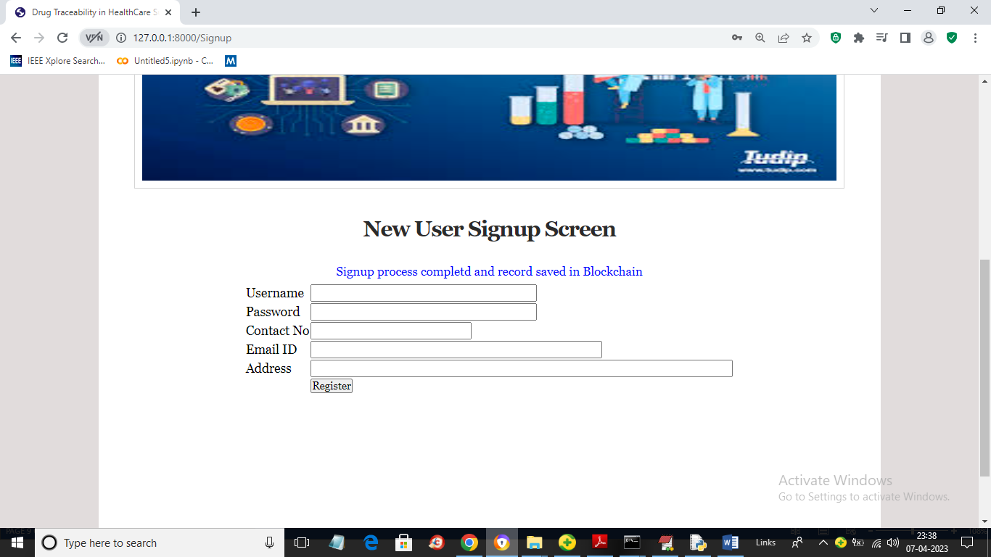
In above screen in blue colour text we can see User details saved in Blockchain and now click on ‘Login’ link to login as user
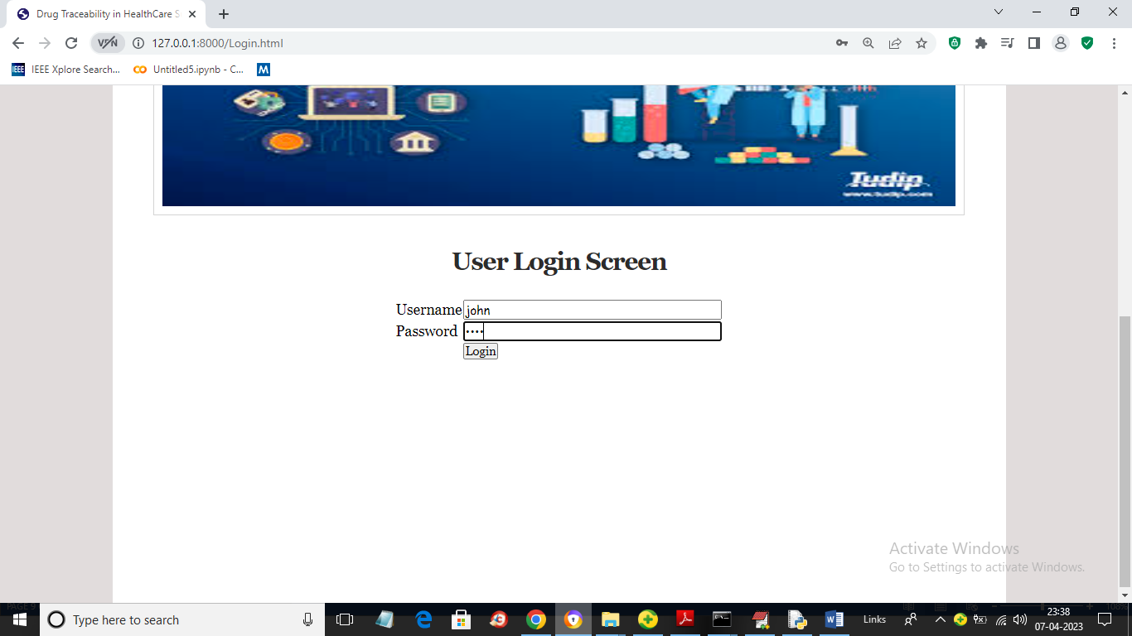
In above screen user is login and after login will get below output
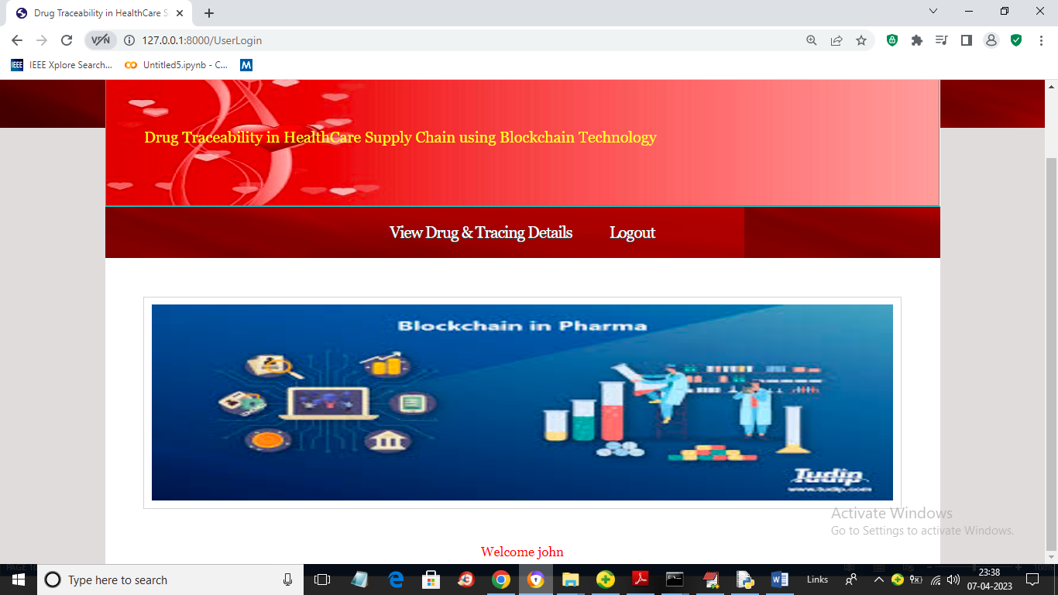
In above screen user can click on ‘View Drug & Tracing Details’ link to get all product details
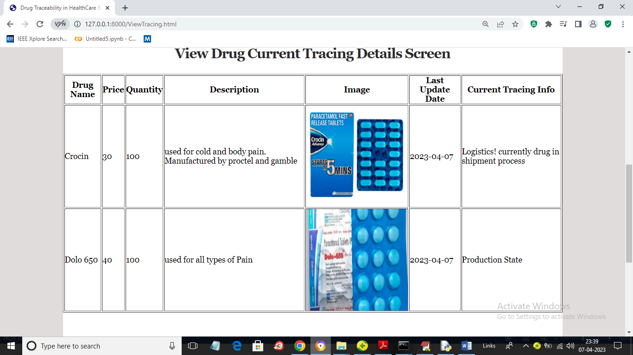
In above screen user can view all product details and in last column user can see current tracing data for each Drug. So by using this application any user can know current tracing and manufacture details of any Drug
8. CONCLUSION:
In conclusion, a blockchain-based supply chain system for drug traceability has the potential to greatly raise the legitimacy and calibre of medicines sold on the international market. Such a system might offer an effective and dependable way of tracking and tracing medications along the supply chain thanks to the decentralised and secure nature of blockchain technology. But there are obstacles that must be overcome for a blockchain-based supply chain system for drug traceability to be adopted and implemented successfully. Various stakeholders, including manufacturers, regulatory agencies, and distributors, will need to work together and support this. It will also need the creation of reliable and established methods for data management and entry. Overall, the process of proposing and evaluating a blockchain-based supply chain system for drug traceability has provided valuable lessons on the potential benefits and challenges of such a system. Further research and development will be necessary to fully realise the potential of blockchain technology in the healthcare industry.
9. REFERENCES:

[1] Dreiher, D., Blagorazumnaya, O., Balicer, R. and Dreiher, J., 2020. National initiatives to promote quality of care and patient safety: achievements to date and challenges ahead. Israel Journal of Health Policy Research, 9 (1).
[2] Kruk, M. E., Gage, A. D., Arsenault, C., Jordan, K., Leslie, H. H., Roder-DeWan, S., Adeyi, O., Barker, P., Daelmans, B., Doubova, S. V., English, M., Elorrio, E. G., Guanais, F., Gureje, O., Hirschhorn, L. R., Jiang, L., Kelley, E., Lemango, E. T., Liljestrand, J. and Malata, A., 2018. High-quality health systems in the Sustainable Development Goals era: time for a revolution. The Lancet Global Health [online], 6 (11), e1196–e1252. Available from: https://www.thelancet.com/journals/langlo/article/PIIS2214- 109X(18)30386-3/fulltext?_hsenc=p2ANqtz9j71i5H1n10wxx2NBq1ut2hYmpqLOEIQX0LxCN_gMwn8mnEO34buRcJMq9R0YratlH91E.
[3] Bombard, Y., Baker, G. R., Orlando, E., Fancott, C., Bhatia, P., Casalino, S., Onate, K., Denis, J.-L. and Pomey, M.-P., 2018. Engaging patients to improve quality of care: A systematic review. Implementation Science [online], 13 (1), 1–22. Available from: https://implementationscience.biomedcentral.com/articles/10.1186/s1 3012-018-0784-z.
[4] Jadhav, J. S. and Deshmukh, J., 2022. A review study of the blockchain-based healthcare supply chain. Social Sciences & Humanities Open, 6 (1), 100328.
[5] Choi, T.-M., 2019. Blockchain-technology-supported platforms for diamond authentication and certification in luxury supply chains. Transportation Research Part E: Logistics and Transportation Review, 128, 17–29.
[6] Katsaliaki, K., Galetsi, P. and Kumar, S., 2021. Supply Chain Disruptions and resilience: a Major Review and Future Research Agenda. Annals of Operations Research [online], 1 (1). Available from: https://link.springer.com/article/10.1007/s10479-020-03912-1.
[7] Rotunno, R., Cesarotti, V., Bellman, A., Introna, V. and Benedetti, M., 2014. Impact of Track and Trace Integration on Pharmaceutical Production Systems. International Journal of Engineering Business Management, 6, 25.
[8] Kootstra, J. and Kleinhout-Vliek, T., 2021. Implementing pharmaceutical track-and-trace systems: a realist review. BMJ Global Health, 6 (Suppl 3), e003755.
[9] Sarkar, S., 2022. Pharmaceutical Serialization : A Challenge for Small Manufacturers. International Journal of Scientific Research in Computer Science, Engineering and Information Technology, 174– 181.
[10] Haji, M., Kerbache, L., Sheriff, K. M. M. and Al-Ansari, T., 2021. Critical Success Factors and Traceability Technologies for Establishing a Safe Pharmaceutical Supply Chain. Methods and Protocols, 4 (4), 85.
[11] Turkanovic, M., Holbl, M., Kosic, K., Hericko, M. and Kamisalic, A., 2018. EduCTX: A Blockchain-Based Higher Education Credit Platform. IEEE Access [online], 6, 5112–5127. Available from: https://ieeexplore.ieee.org/document/8247166 [Accessed 23 Nov 2019].
[12] Sedlmeir, J., Lautenschlager, J., Fridgen, G. and Urbach, N., 2022. The transparency challenge of blockchain in organisations. Electronic Markets.
[13] Skh Saad, S. M. and Raja Mohd Radzi, R. Z., 2020. Comparative Review of the Blockchain Consensus Algorithm Between Proof of Stake (POS) and Delegated Proof of Stake (DPOS). International Journal of Innovative Computing, 10 (2).
[14] Huang, Y., Wu, J. and Long, C., 2018. Drug Ledger: A Practical Blockchain System for Drug Traceability and Regulation [online]. IEEE Xplore. Available from: https://ieeexplore.ieee.org/document/8726740 [Accessed 8 Jun 2021].
[15] Jamil, F., Hang, L., Kim, K. and Kim, D., 2019. A Novel Medical Blockchain Model for Drug Supply Chain Integrity Management in a Smart Hospital. Electronics [online], 8 (5), 505. Available from: https://www.mdpi.com/2079-9292/8/5/505/htm.
[16] Muniandy, M., Ong, G. and Ern, T., 2019. Implementation of Pharmaceutical Drug Traceability Using Blockchain Technology. INTI JOURNAL | eISSN [online], 2019, 35. Available from: http://eprints.intimal.edu.my/1308/1/vol.2019_035.pdf [Accessed 12 Jan 2023].
[17] Shah, K. and Grant, E., 2022. Towards Simplifying and Formalizing UML Class Diagram Generalization/Specialization Relationship with Mathematical Set Theory. 2022 the 6th International Conference on Information System and Data Mining.
[18] Abbas, K., Afaq, M., Ahmed Khan, T. and Song, W.-C., 2020. A Blockchain and Machine Learning-Based Drug Supply Chain Management and Recommendation System for Smart Pharmaceutical Industry. Electronics [online], 9 (5), 852. Available from: https://www.mdpi.com/2079-9292/9/5/852/htm [Accessed 16 Jun 2020].
[19] Tikhomirov, S., Voskresenskaya, E., Moscow, S., Alexandrov, Y., Ivanitskiy, I., Takhaviev, R. and Marchenko, E., 2018. SmartCheck: Static Analysis of Ethereum Smart Contracts. [online], 8. Available from: https://s-tikhomirov.github.io/assets/papers/smartcheck.pdf.
[20] Center for Drug Evaluation and Research, 2019. Drug Supply Chain Security Act (DSCSA) [online]. U.S. Food and Drug Administration. Available from: https://www.fda.gov/drugs/drug-supply-chainintegrity/drug-supply-chain-security-act-dscsa.

